Kiana Jackson, a senior at University Heights, and Anabel Simotas, a junior at Fieldston.
Fieldston and University Heights are in the same borough but worlds apart. How much understanding between their students can a well-told story bring?

A Tale of Two Schools: NY Times Magazine –
May 2, 2014
University Heights High School is on St. Anns Avenue in the South Bronx, which is part of the poorest congressional district in America, according to the Census Bureau. Six miles away is the Ethical Culture Fieldston School, with its arched stone entrance and celebrities’ children and $43,000-a-year tuition. Eight years ago, as part of a program called Classroom Connections, students from the schools began exchanging letters, which eventually led to a small group from University Heights visiting Fieldston for a day. “At the time in our school, these were tough street kids,” said Lisa Greenbaum, who has been teaching English literature at University Heights for 10 years. “They walked into Fieldston, and they were just overwhelmed. They couldn’t imagine that this was just minutes from where they lived, and they never even knew about it. One kid ran crying off campus. It made them so disheartened about their own circumstances.”
Over the next eight years, the two schools maintained their connection, groups of students meeting intermittently to talk about race relations, say, or gun violence, or to take a combined field trip to work on a community-garden project in Van Cortlandt Park. They most recently got together in early April to participate in an exercise in “radical empathy,” as it’s called by the group Narrative 4, which facilitates story exchanges between groups from all over the world.
Under the supervision of Narrative 4, the students paired off, one from each school, and shared stories that in some way defined them. When they gathered as a group a few hours later, each student was responsible for telling the other’s story, taking on the persona of his or her partner and telling the story in the first person (“shattering stereotypes by walking in each other’s shoes,” as one of the Narrative 4 facilitators put it).
It was a fairly remarkable thing to watch, the care each student took with the story that had been entrusted to her or him. David Fishman told the story of Angie Ramirez, whose father had died and whose mother had been sick. “I’m afraid of her going away,” David-as-Angie said. (“I shared a story about my Outward Bound trip last year,” David later wrote to me, as a way of talking about his awareness of the different kinds of strain in their lives, “and how I had to overcome peer pressure and stand up for what I believed in. My partner talked about her father’s death and an illness her mother had. She expressed fears about having to take care of her little siblings if her mother died.”)
The rest of the students’ stories ranged from the lighthearted (the first time I got drunk; my love of bowling) to the profound — stories of temporary homelessness and family suicides, of academic pressure and shame about being poor, of the struggle to help a mother overcome her troubles and find the physical and spiritual strength to turn her life around. That last story, which belongs to Johnny Rivera, was told to the group by Adam Ettelbrick. When it came time for Johnny to tell Adam’s story, about a first date that ended in the rain in Central Park — dancing, kissing, young love — he sold it completely. “It was so important to him,” Johnny said afterward. “And now it was kind of my story, too. So it was really important to me to get it right.” JOEL LOVELL
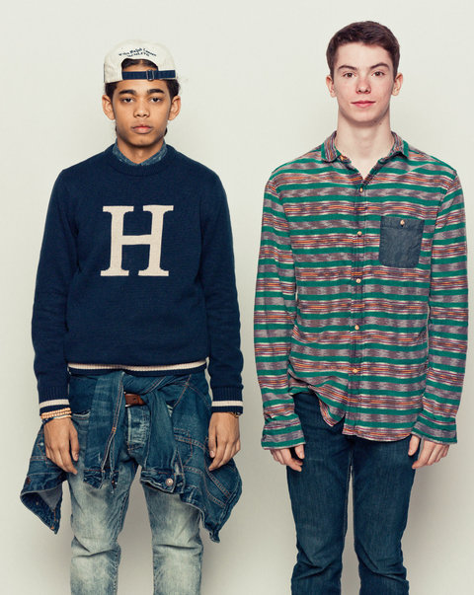
Johnny RiveraUniversity HeightsAge 18Grade 12Adam EttelbrickFieldstonAge 17Grade 11
Johnny RiveraSchool University Heights Age 18 Grade 12
Adam EttelbrickSchool Fieldston Age 17 Grade 11
Johnny “I’m very aware of the financial realities in my community, and that most or all are low-class citizens like myself. We struggle every day and watch our parents struggle to feed us and pay for necessary things. But I’m a dreamer and an innovative person, and I think that achievement is more meaningful than actual income.”
Adam “As a kid, you’re unaware that there are people who don’t have what you have. Then you realize, Oh, my God, there are people who don’t have anything like what I have. And you realize you’ve been given an unfair advantage. It’s my responsibility to use that advantage for social justice and to make the world a better place.”
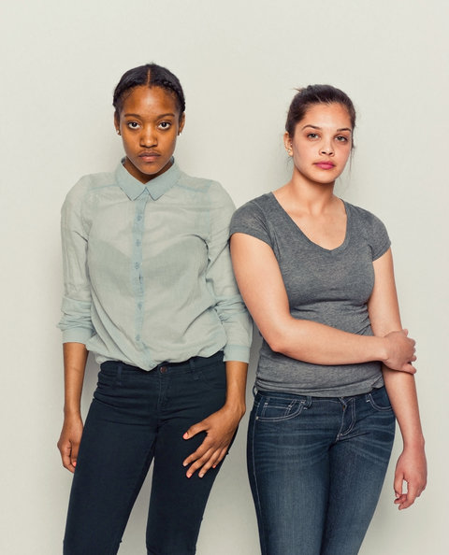
Marienely QueroUniversity HeightsAge 17Grade 12Ashley ElsonFieldstonAge 17Grade 11
Marienely QueroSchool University Heights Age 17 Grade 12
Ashley ElsonSchool Fieldston Age 17 Grade 11
Marienely “People in my community have welfare and Section 8. My family doesn’t receive that aid anymore, but we once did, so I know how it feels to let people know you receive help from the government. Sometimes I get stressed just seeing my mother working so hard to get me what I want and need. The only thing she asks for is for me to do great in school, but I wish I could get a job to help her out. She’s my motivation in life.”
Ashley “I am a TEAK Fellow at Fieldston. TEAK is an organization that helps low-income students gain admission to prestigious private high schools and colleges. I wish conversations about class and wealth would happen at Fieldston, but socioeconomic status is one of the hardest things to have open conversations about. How do you make people feel safe and included without being too vulnerable?”
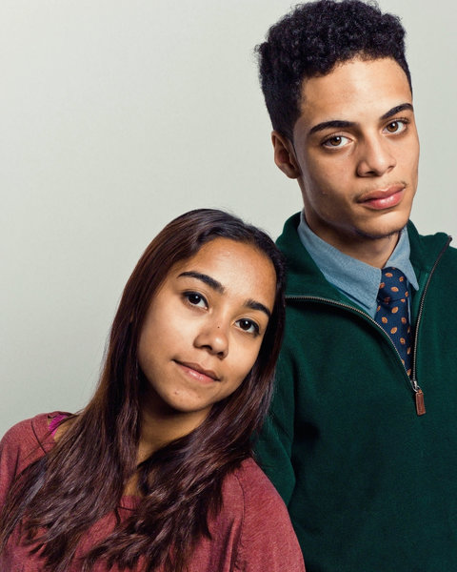
Madison DeJesusFieldstonAge 17Grade 12Anthony PeñaUniversity HeightsAge 18Grade 12
Madison DeJesusSchool Fieldston Age 17 Grade 12
Anthony PeñaSchool University Heights Age 18 Grade 12
Madison “I went to public school until seventh grade, so I am hyperaware of the disparity between Fieldston and a public school. For example, the University Heights students come here and are amazed by our lunch selection, and Fieldston students bash the caf because they just don’t know it could be worse. When I’m with the University Heights kids, I feel wealthy, to an extent. But when I’m with Fieldston kids, I feel like I have less than enough.”
Anthony “Money is an ongoing topic in my community, because everyone wants. My friends may not be the wealthiest, but everyone has a great story and wisdom to share, to help you forget about all the things you want and cherish all the things you actually have.”
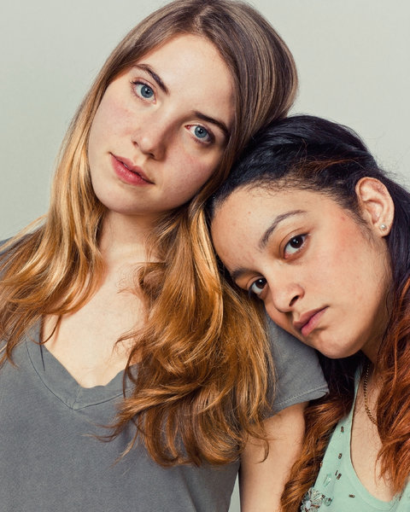
Anabel SimotasFieldstonAge 16Grade 11Kiana JacksonUniversity HeightsAge 17Grade 12 Ryan Pfluger
Anabel SimotasSchool Fieldston Age 16 Grade 11
Kiana JacksonSchool University Heights Age 17 Grade 12
Anabel “I’m very lucky and privileged to have the parents I have. They’ve never stressed money in my life, which has given me an idea of success that isn’t based on money, but rather happiness and self-fulfillment. This may be because my family hasn’t ever openly struggled financially in my lifetime. I don’t usually think of money in a social context — who has more and who has less — but again, maybe this is due to the fact that I’ve never personally struggled to make money or get by.”
Kiana “I went in there thinking none of the students at Fieldston would understand what any of the kids from my school go through on a daily basis, because they’re most likely all from rich households. But my partner and I had a lot more in common than I thought we would, and these kids were not stuck up like I thought they’d be. Some of them went through similar things that kids from my school have gone through — in some cases, maybe worse.”
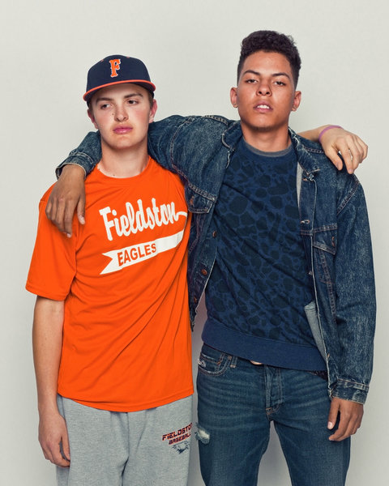
Ellis MaxwellFieldstonAge 17Grade 11Nagib GonzalezUniversity HeightsAge 18Grade 12
Ellis MaxwellSchool Fieldston Age 17 Grade 11
Nagib GonzalezSchool University Heights Age 18 Grade 12
Ellis “When I meet with the students from University Heights, the obvious differences in our situations do play a factor in the conversation. But then a funny thing happens: You start to find out things you have in common. I talked with one student, and we immediately went to the topic of baseball. We had very similar experiences, even though some of our other experiences were nothing alike. We get much more out of realizing our similarities.”
Nagib “My mom works really hard for a little bit of money. I used to be ashamed to admit this, but now I embrace it. Being poor is the biggest motivation for me because I come from the bottom, and my goal is to reach the top. People say that success is not determined by income, and I mostly agree, but I want my success to be determined by income. I want to be able to support my family. Also, most of the things that I worry about now are money-related, and I don’t want my children to have to worry like my siblings and I did.”
Nicholas PollardUniversity HeightsAge 18Grade 12Juliet LewisFieldstonAge 17Grade 12
Nicholas PollardSchool University Heights Age 18 Grade 12
Juliet LewisSchool Fieldston Age 17 Grade 12
Nicholas “Some people don’t have as much as I do. This is why I do not complain at all about what I have. Some have more than me. But it’s all right, because I am content with life. One of the most valuable things I own is my dad’s bracelet. Since he passed, I really don’t have much to remember him by. He’s buried in my country — Guyana — so the bracelet that he once owned is one of the things I value the most.”
Juliet “We’re trained from a very young age to search for clues about money in the slightest details. And, of course, money matters. It would be untrue to say we spent an afternoon telling each other’s stories and ‘got past that whole difference in class thing.’ But when you tell someone’s story, that’s something precious, and you have to take care of it, you have to take care of them. Afterward, as my partner was making me laugh during all the ‘serious face’ photos, I was really grateful that he had taken as much care with my story as I tried to with his.”
Angie RamirezUniversity HeightsAge 18Grade 12David FishmanFieldstonAge 17Grade 11
Angie RamirezSchool University Heights Age 18 Grade 12
David FishmanSchool Fieldston Age 17 Grade 11
Angie “Most of my peers are in the same predicament as I am, of not being able to afford a private education. So that’s the group I relate to — kids who are trying to get an education to make themselves better or help their families out. We want to get out of the hood and get a good job in order to have a better future.”
David “I consider my family to be in the upper middle class. We are well off and can afford the luxury of vacations, a private education, an apartment in New York City. However, many of my friends are much wealthier than I am, and sometimes this makes me feel inadequate and somewhat ashamed. But I recognize the unbelievable privilege I have, too, and my financial situation only motivates me to use it wisely.”
Amy PerezUniversity HeightsAge 18Grade 12Lisa SlivkenFieldstonAge 17Grade 12
Amy PerezSchool University Heights Age 18 Grade 12
Lisa SlivkenSchool Fieldston Age 17 Grade 12
Amy “It’s only my mom and me, and my mother breaks her back to pay bills so we’ll be able to live a decent life. It just makes me want to have two jobs instead of one so she could stop working. I know I can’t do that, though, so I constantly think about college and my career and how much money I’ll make so she can finally stop working. I just want to make her life easier and thank her for supporting me on her own.”
Lisa “At a school with such a dominant culture of affluence, it is hard not to be conscious of where you fall along the spectrum, especially if you don’t feel fully comfortable in this culture. I definitely have a skewed perception of financial success. My parents’ concerns about their jobs and being able to put me and my sister through school stress me out and sometimes make me feel isolated here. But my understanding of financial hardship is completely relative, because I know feeling slight discomfort in a private-school environment is far from true suffering.”
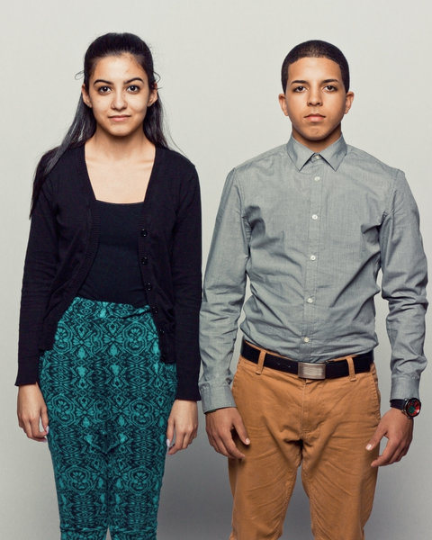
Christina FranquiFieldstonAge 17Grade 12Anthony BracheUniversity HeightsAge 18Grade 12
Christina FranquiSchool Fieldston Age 17 Grade 12
Anthony BracheSchool University Heights Age 18 Grade 12
Christina “I am very aware of my family's financial situation at all times, especially at school. There are many instances when a conversation about clothing is happening, and some of the students are able to purchase clothing that I would never be able to because of my financial situation. While I have less money than many of the students that I go to school with, I am also aware of my privilege in regard to the rest of the world and realize that I, in no way, have it worse than most people.”
Anthony “I think of myself as a low-income individual, for now. I know my day will come and that I will make a change in my life that will effect me financially and mentally. When I think of my future success, income does play a large role, because I want to live comfortably and travel and have money to support a family of my own. But I also know that success comes from within. You aren't truly successful until you are happy with the life you are living.”
Caroline DanehyFieldstonAge 17Grade 11Elio VelazquezUniversity HeightsAge 18Grade 12
Caroline DanehySchool Fieldston Age 17 Grade 11
Elio VelazquezSchool University Heights Age 18 Grade 12
Caroline “I live in Larchmont, New York, which is a fairly wealthy area, with not much diversity. My dad and mom grew up in different financial situations. But my dad grew up in upstate New York with four brothers and constantly moving from house to house, and my mom grew up on the Upper East Side of Manhattan, living in one apartment her whole life. My dad has strived his whole life to give his family a better life financially and emotionally than he had while growing up. I feel very proud of my family’s financial situation, because I know how hard he has worked so we are able to live the life we live.”
Elio “When I first met with the Fieldston students, I felt out of place. I saw the campus and was fascinated by its resemblance to a college. I noticed that most of the students there were Caucasian and dressed preppy. I come from a school the majority of the student population is Hispanic. But I was struck by how open and welcoming these people were to outsiders. Growing up, I stressed about money all the time, but that made me more appreciative of the luxuries I do have. Still, my most valuable belonging is the yellow stuffed bear my mother gave me when I was about 4. I keep him because he reminds me of my past and the struggles I have overcome.”

