Assignment: Missing Child Poster
Your job is to create a “Missing Child” poster for a child from your assigned country. Your missing child should resemble the circumstances that average children from that country are faced with on a daily basis. For example, we looked at kids in the Philippines, who were diving in underwater gold mines. If your missing child is from the Philippines, that might be what they were doing when they went missing.
Requirements
Poster must be one 8.5 X 11 page – no more, no less.
Must include photo or sketch – but no bigger than 2 X 3 inches.
Child’s age – or estimated age
Must include a description of what the child was doing when he/she disappeared
Must include a description of the child’s family

Optional items to include
Does / did the child attend school
What type of clothes was he/she wearing
Possible health issues
Is missing child possibly linked to some criminal activity
Family circumstances

Helpful Websites:
CIA Factbook just google “CIA Factbook”

Work days:_______________________________________ Due: ________________________

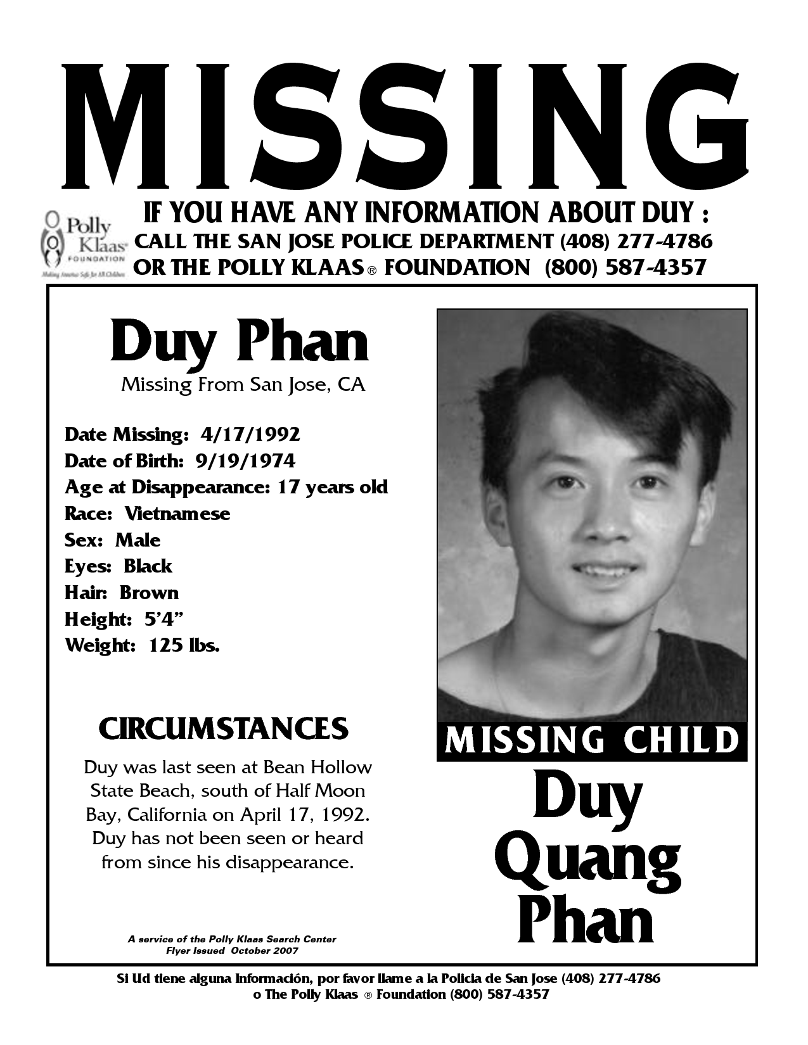

List of nations / Areas
1 - Syria
2 – Haiti
3 – US / Mexico Border region
4 – Chicago’s South Side
5 – South America – you choose the country
6 – Rural United States
7 – Gaza
8 – West Bank
9 – North Korea
10 – South Korea
11 – Iraq
12 – Afghanistan
13 – Any nation in Europe – you pick
14 – Russia
15 – China
16 – Israel
17 – Egypt
18 – Mexico
19 – India
20 – Central Africa – you choose the country
21 – Cuba
22 – Puerto Rico
23 - Guatemala

