The ‘saddest bride I have ever seen.’ Child marriage is as popular as ever in Bangladesh
The Washington Post – August 29, 2015
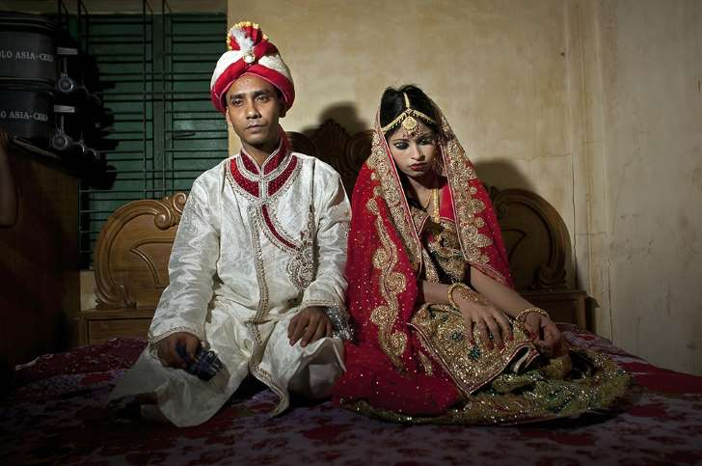
On her wedding day 15-year- old Nasoin Akhter looked “melancholic,” according to photographer Allison Joyce who documented the teenage girl’s wedding to her 32-year-old husband Mohammad Hasamur Rahman last week in Manikganj, Bangladesh.
“It’s tradition for the bride to look shy and coy during the wedding” Joyce told The Washington Post in an email. “But I noticed this sadness and unspoken fear and uncertainty even when she was in her room with her friends before the ceremony or at the parlor with her sister (who was also married around the same age). She was withdrawn and quiet. ”
Although Nasoin Akhter’s marriage is technically illegal in Bangladesh, laws against child marriage are rarely enforced. And despite what government officials promise and the fact that outside organizations consider it a human rights violation, it remains popular in Bangladesh. According a report published in June by Human Rights Watch, the country has the fourth highest rate of child marriage in the world with 29 percent of Bangladeshi girls married before the age of 15, and 65 percent before the age of 18.
“Child marriage around the world is associated with many harmful consequences, including health dangers associated with early pregnancy, lower educational achievement for girls who marry earlier, a higher incidence of spousal violence, and an increased likelihood of poverty” the report states. “Global data shows that girls from the poorest 20 percent of families are twice as likely to marry before 18 as girls whose families are among the richest 20 percent.”
Poverty, tradition, the sexual harassment of unmarried girls, and limited access to education drives the practice, convincing parents that they’re doing what’s best for their daughters, according to the report.
On Instagram, Joyce wrote that Nasoin Akhter’s was the “saddest bride I have ever seen,” and the photographer told The Post what she found surprising about Akhter’s wedding was her family wasn’t poor. “What was surprising to me is that Nasoin is from a very wealthy family. One of the causes cited for child marriage is poverty, but her father is a wealthy businessman, with multiple two story houses. Around 2,000 people were invited to the wedding, and they slaughtered hundreds of chickens and a dozen large cows to feed the guests.”
Joyce, who is based in Bangladesh, has photographed other child marriages. Another young bride, 14-year-old Mousammat Akhi Akhter said she felt wanted to wait until she was older when she married 27-year-old Mohammad Sujon Mia last year but as Joyce reports social pressure and tradition persuaded her parents to marry her just after she had finished 6th grade.
“Before their weddings they had dreams, they both loved school and had hopes for the future. Akhi’s favorite subject was math and she wanted to be a teacher, before she was married off at 13.” Joyce told the Post. “She said that her father supported her education but her mother saw nothing wrong with child marriage as it has been a norm in their village and community and thought it would be best for her. She told me she was frightened, that she wasn’t ready to get married.”
But it’s not only the desperation of poverty or social pressure that drives child marriage, it’s protection. “I photographed the wedding of Akhi’s 13 year old sister last year, and when I asked her mother why she was marrying her daughter off, she described not feeling comfortable to let her walk to the corner store because she would be harassed by men and boys.” Joyce said. “She also said no boy wants to marry a girl older than 18, if a girl is still single past that age people will ask too many questions. She knew it was wrong to marry very early, but they weren’t from a wealthy family, and she told her daughter’s husband to wear condoms for a few years, so it will be okay. Marriage is seen as a cover of respect and protection for women. By not going to school, it reduces the risk of being sexually active outside the house or be harassed while commuting,” Joyce said.
Even though Bangladesh has cleaned up its act on many issues such as reducing poverty, maternal mortality, achieving gender parity in primary and secondary school enrollment, and straightening women’s rights, it still struggles to tackle child marriage according to the report. The Bangladesh governments proposed plan to tackle this issue has raised awareness of the issue but one of its strategies was to lower the legal marriage age from 18 to 16. But after an international outcry of criticism it was put on hold. On a local level “widespread complicity” by officials has facilitated many of the child marriages. “Interviewees consistently described local government officials issuing forged birth certificates showing girls’ ages as over 18, in return for bribes of as little as US$1.30.” the report reads.
“The Bangladesh government has said some of the right things, but its proposal to lower the age of marriage for girls sends the opposite message.” Heather Barr, senior researcher on women’s rights said to Human Rights Watch. “The government should act before another generation of girls is lost.”
“Working on this issue has been very troubling.” Joyce said. “The only difference between these girls and me is that I happen to have been born into a country and culture that respects girls and women, and sees a woman’s value in a society beyond the role of a mother or a wife. Seeing their future, their possibilities and potential being ripped away from these girls in the span of one night is equal parts heartbreaking and infuriating for me. I don’t think it will be possible for countries to develop to their full potential until women and men stand on equal footing.”

