Thousands of migrant children are trekking hundreds of miles in a caravan to the US. These powerful pictures show their difficult journey.

Reuters – Nov. 1, 2018 https://www.thisisinsider.com/migrant-caravan-children-photos-mexico-2018-11
Michelle Mark
Nov. 1, 2018, 1:16 PM
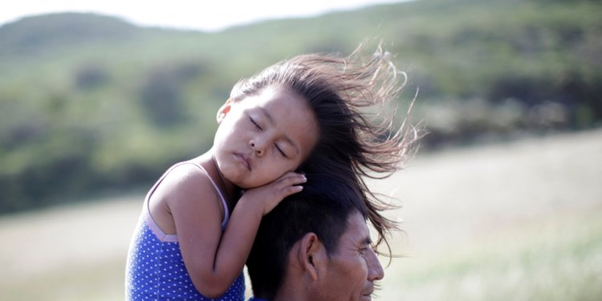Reuters/Ueslei Marcelino
The caravan of migrants making their way through Mexico to the United States has been characterized by some Americans as a national-security threat or an "invasion" — but less talked-about are the thousands of young children making the journey.
Last week, UNICEF pegged the number of children at an estimated 2,300, but the caravan has been dwindling as it moves further north and exhaustion and sickness is causing migrants to give up.
It's unclear how many are still traveling, how many may try to stay in Mexico, and how many have returned to their home countries.
Humanitarian teams working with the caravan have expressed concern about the children's welfare, and noted that some of them have already become sick or dehydrated.
"The long and arduous journey has left children exposed to inclement weather, including dangerously hot temperatures, with limited access to proper shelter," UNICEF said in a statement last week.
Here's a glimpse at what the youngest members of the caravan are going through.

The caravan originally started in mid-October as a group of several hundred migrants who set out from San Pedro Sula, Honduras.
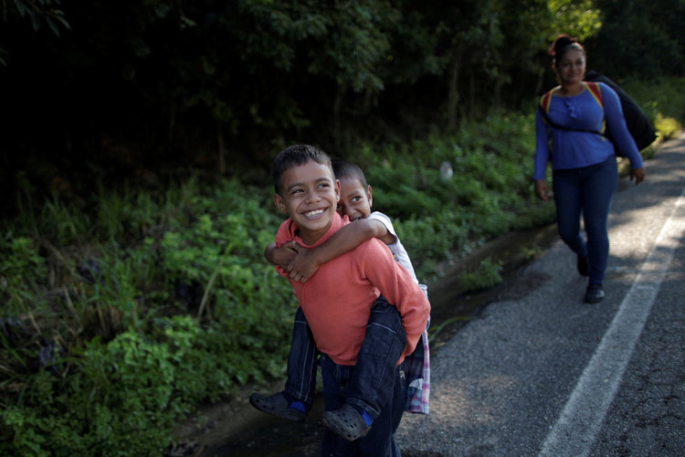Denzel, 8, holds his brother Adonai, 5, near their mother Glenda Escobar, a migrant from Honduras, part of a caravan of thousands from Central America en route to the United States, as they walk to Pijijiapan from Mapastepec, Mexico, October 25, 2018. Picture taken October 25, 2018. Reuters/Ueslei Marcelino
Source: INSIDER

Their ranks quickly swelled as word of the caravan spread, reaching an estimated peak of more than 7,000 migrants when they entered Mexico on October 19 — and nearly one-third of them were children.
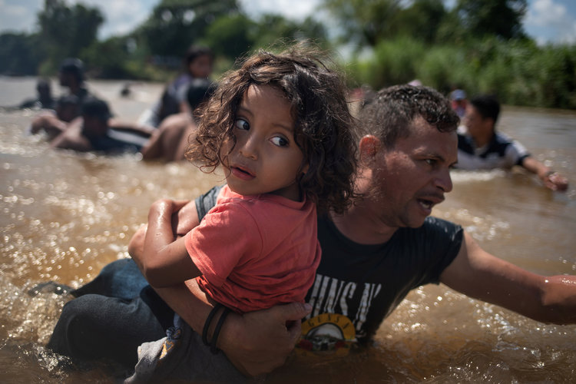Luis Acosta holds five year old Angel Jesus, both from Honduras, as a caravan of migrants from Central America en route to the United States crossed through the Suchiate River into Mexico from Guatemala in Ciudad Hidalgo, Mexico October 29, 2018. Reuters/Adrees Latif
Source: UNICEF

Though President Donald Trump and his allies have painted the caravan as a sinister force, made up of "bad thugs and gang members" and "some very tough fighters," a major chunk of the migrants are young and vulnerable.
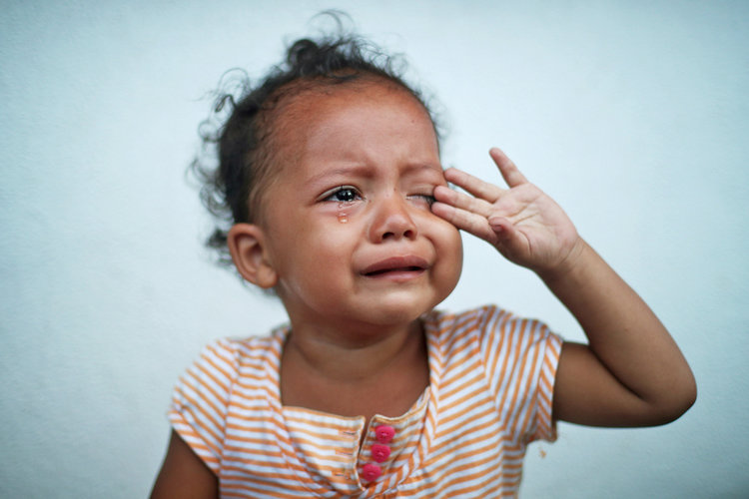Eileen Abisai Hernandez, a one-year-old migrant girl from Honduras, part of a caravan of thousands from Central America en route to the United States, cries because she is unwell as she rests in Tapanatepec, Mexico, October 28, 2018. Reuters/Hannah McKay
Source: Twitter/@realDonaldTrump

The kids range in age from early infancy to older teenagers traveling without their parents.
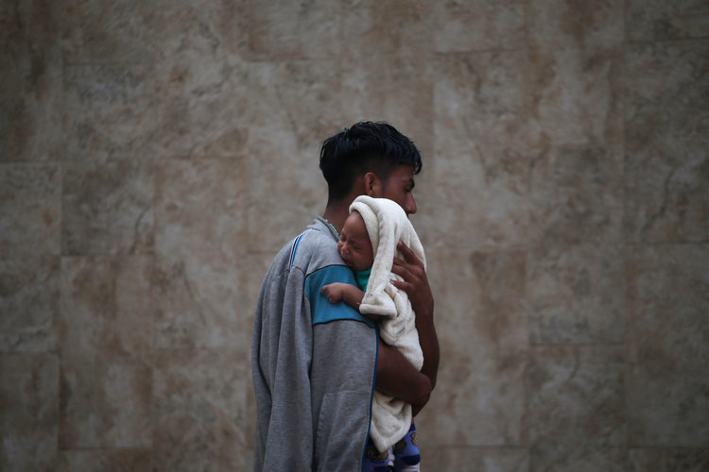A Central American migrant making their way to the U.S. in a large caravan carries his son after arriving in Tapachula, Mexico, Sunday, Oct. 21, 2018. Associated Press/Moises Castillo

A pregnant woman was even removed from the rest of the group by ambulance in Juchitan, Mexico, on Tuesday night. She gave birth to a baby girl, the first known infant born on the caravan's journey, and is still receiving medical attention at a hospital, according to Mexican officials.
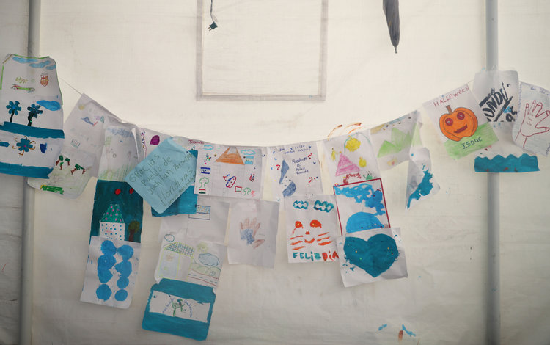Migrant children drawings hang on the wall of a makeshift camp in Juchitan, Mexico, October 31, 2018. Reuters/Hannah McKay
Sources: The Arizona Republic, Associated Press

Many of the children are fleeing dangerous or tragic conditions in Northern Triangle countries including severe poverty, lack of education, widespread crime, and gang violence.
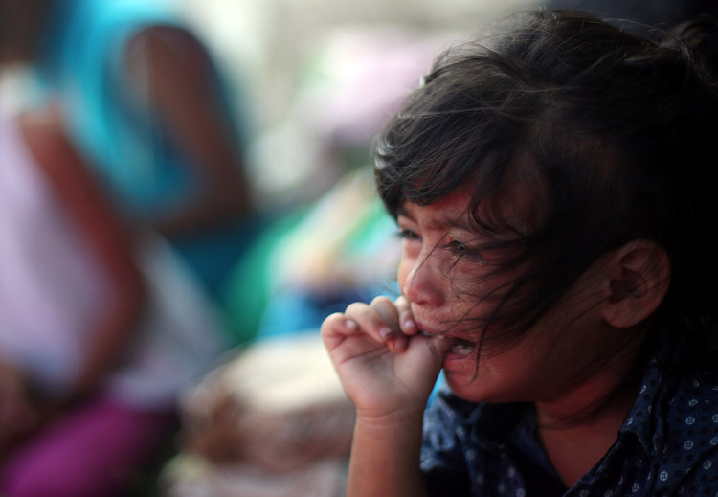Yolani, a one-year-old migrant girl traveling from Honduras, part of a caravan of thousands from Central America en route to the United States, cries because she is hungry as she rests on the roadside in Santiago Niltepec, Mexico, October 29, 2018. Reuters/Hannah McKay
Sources: UNICEF, INSIDER

Some of the children are too young to fully understand why they and their families are making the trek, though some reportedly view the journey as more of an adventure than an escape.
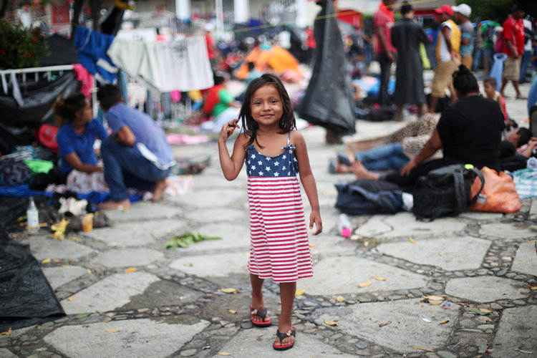Chelsy Montserrat Maldonado, a four-year-old migrant girl from Honduras, part of a caravan of thousands from Central America en route to the United States, wears a U.S. flag themed dress as she stands in a makeshift camp as they take rest in Tapanatepec, Mexico, October 28, 2018. Reuters/Hannah McKay
Source: Washington Post

One six-year-old migrant girl told the Washington Post she liked walking in the caravan with her mother each day, and explained that they didn't hitch rides in the back of trucks like some other migrants because "you can trip and fall and die."
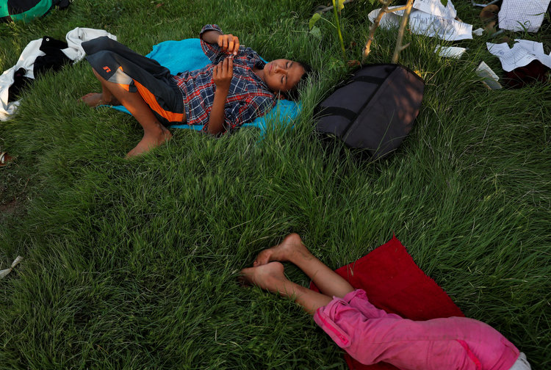Migrants, Julian Zelaya, 12, and his sister Jasmine Zelaya, 10, part of a caravan traveling to the U.S., rest at in a small town after crossing the river from Guatemala to Mexico in Ciudad Hidalgo and continuing to walk in Mexico October 29, 2018. Reuters/Leah Millis
Source: Washington Post

The route and future of the caravan is still up in the air. Their numbers may not stay in the thousands as they progress north through Mexico, they may not stay together as one large group, and they still have not clarified exactly where along the 2,000-mile US-Mexico border they plan to cross.
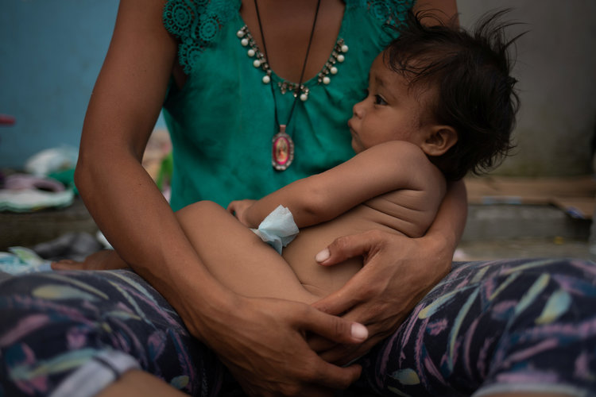Estephanie, a one-year-old migrant girl from Honduras, is held by her mother while resting amid thousands from Central America en route to the United States, in Huixtla, Mexico October 23, 2018. Reuters/Adrees Latif
Source: Associated Press

The caravan is still roughly 900 miles from the closest part of the US-Mexico border in Texas, and they have been largely making the journey on foot and via hitch-hiking.
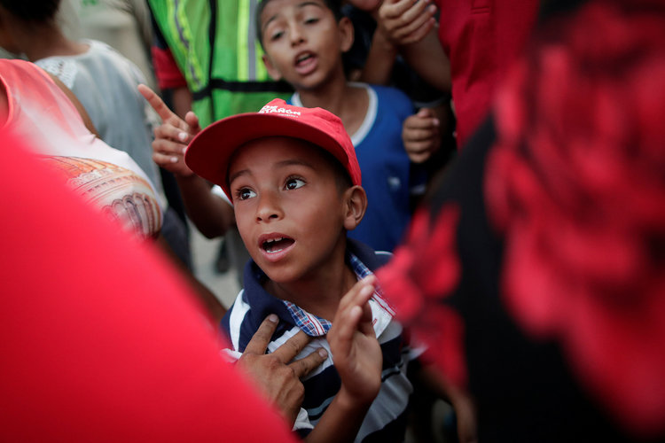Children line up for food donations as families from Central America, part of a caravan of thousands of migrants en route to the United States, travel through San Pedro Tapanatepec, Mexico October 28, 2018. Reuters/Ueslei Marcelino
Source: INSIDER

Though the group tried to organize buses to take the group up to Mexico City, the government refused to provide them.
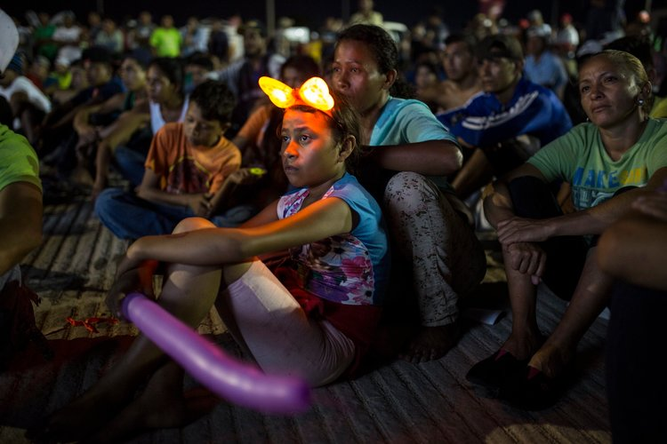Central American migrants watch a movie set up at their makeshift camp where a caravan of thousands of Central American migrants are sleeping in Juchitan, Mexico, Tuesday, Oct. 30, 2018. Associated Press/Rodrigo Abd
Source: Associated Press

Meanwhile in the US, the Trump administration has praised the Mexican government for slowing the caravan, forcing them to complete the journey on foot, and is set to deploy up to 15,000 military personnel to the border.
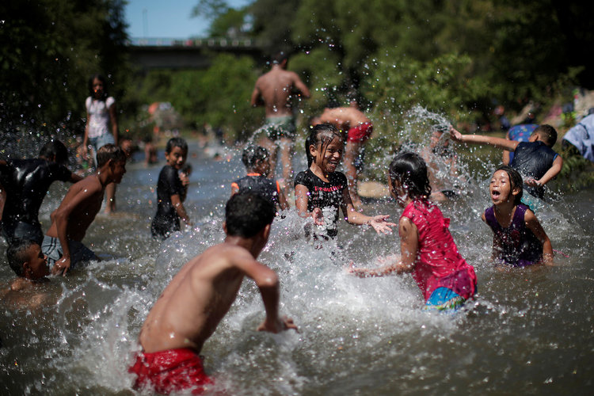Migrants, part of a caravan of thousands of migrants from Central America en route to the United States, are seen bathing in a fresh water stream, in Tapanatepec, Mexico, October 28, 2018. Reuters/Ueslei Marcelino

