In Afghanistan, school is a luxury that many working children cannot afford
By Los Angeles Times, adapted by Newsela staff Apr. 29, 2014
KABUL, Afghanistan — Sami Rahimi rises at 5 a.m., sweeps up, washes in a pan of chilly water, then prays.
Before the sun has risen, Sami is pushing a dented wheelbarrow through the dim streets. He gathers water from a public well and takes it back to the bakery, where he sleeps on a bread rack over the cold concrete floor. At 13, he is a tiny figure among the vegetable sellers and butchers slicing up sheep carcasses hung from hooks.

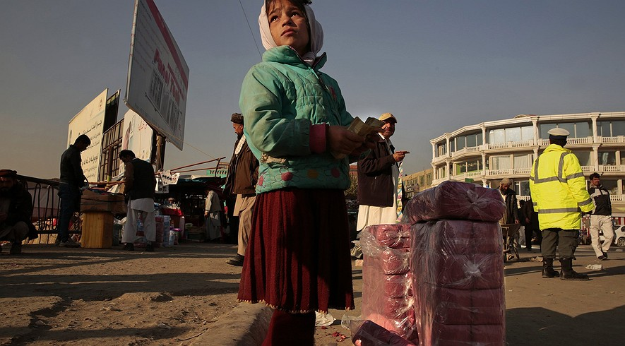Shukriya, 8, sells toilet paper in downtown Kabul, Afghanistan. Although child labor is illegal in the country, it is pervasive due to a lack of enforcement and the need of many families to have as many members earning income as possible. Photo: Carolyn Cole/Los Angeles Times/MCT

By 6 a.m., the stone oven is glowing a fiery red. Dough is flung against its curved walls to bake into the flat loaves known as khasa and the round loaves called kamachi. The sweet smell of fresh bread wafts through the cramped storefront.
Sami sweeps a platform where hot flatbread is stacked for sale. He then sits cross-legged to begin the long hours of selling each loaf for 10 afghanis, about 20 cents.
Working until dark six days a week, Sami earns about $80 a month. It is enough to support his entire family – his disabled father, mother, three brothers and five sisters.
Sami has been at the bakery since he was 10. His uncle, who owns the bakery, himself began working at age 8.
“I’m happy I can support my family, but I would rather go to school and be an educated person,” Sami says, shrugging as he flips over a steaming loaf with his hook. He is the only person in his family with a job.

Daydreams Of School
The work bores him. He daydreams of graduating from a university and becoming a teacher or engineer, a learned man, not a little boy who can barely read and sells bread.
Child labor is common in Afghanistan, despite laws that prohibit children younger than 14 from working full time. It is also forbidden for children younger than 18 to do dangerous work.
But the laws are widely ignored because of resistance from employers and from families who need the income, said Sami Hashemi, a child-protection expert for UNICEF in Afghanistan.
Children as young as 6 work in brick making, carpet weaving, construction, mining and farming. Others beg, collect garbage or sell little toys on the street.
Families scramble for any job to survive. “They must focus on today, not on a future for their children,” said Hashemi, who is frustrated that so many children don't go to school.
The aid organizations that send billions of dollars to Afghanistan have no idea how many Afghan children work. The best estimate is nearly 2 million between the ages of 6 and 17, or at least 25 percent of Afghan children, Hashemi said. The numbers are rising as growth in mining and construction, paid for by international dollars, has lured more underage workers.
A U.S. Labor Department report last year says children are hurt or killed in construction jobs, and forced to work in extreme cold or heat, carry heavy loads, smuggle illegal drugs or serve as soldiers.

Working Hard For $3
On the busy streets of Kabul, skinny kids dart in and around the cars in traffic. They tap at windshields and beg for money, and bother drivers to buy chewing gum, candy, maps, matches, scarves and toilet paper. They collect trash to burn for fuel, and pick through garbage heaps for rotting fruit or half-eaten food.
Taxi drivers pay small boys about 10 cents for each customer they bring.
Abdul Rafi’s voice emerges from his scrawny body as a croak. He says he wore out his voice screaming for taxi customers. He's only 9, but he began working when he was 6.
Abdul is the oldest of three brothers, and it is up to him to find work. In Afghanistan, older sons are expected to support their families. Abdul is up every day at 5 a.m. for morning prayers. Then he rushes to the taxi stands amid the noise of donkey carts, creaky old Toyotas, and Afghan military vehicles filled with gunmen. Most days, he barely earns $3.
“I would rather just go to school,” Abdul says. “But my family needs the money, and I’m the oldest.”
He wants to be a soldier one day — a soldier who can read. He takes off four hours for class on school days, then runs back to catch the late-afternoon rush hour.

"Stuck Inside This Bakery"
At the bakery, Sami Rahimi's uncle says he too supported his entire family when he started working when he was 8 years old.
“Young boys have always worked in bakeries. That’s our tradition,” Mohammed says, shrugging about the child-labor laws that he doesn't follow.
Mohammed blames Western aid groups for not doing more to find alternatives for poor families and their children.
“Billions of dollars have come to Afghanistan,” he says, shouting to be heard over the noise of customers and the oven. “Where did it go? Wasted. Stolen. The system is corrupt, and the Americans are part of it.”
Billions of dollars flow into Afghanistan to help the reconstruction of the war-torn country, but reports say that much of the money has been wasted or stolen.
Mohammed has promised Sami’s father that the boy will be educated. “I don’t want this boy to have my life stuck inside this bakery,” he says.
Sami feels lucky he has a job, but his mind is focused on the future.
“I think always about my lessons,” he says. “I think about my future, which is my education.”
About once a week, Sami speaks with his mother on a borrowed cellphone. He has not been home in 45 days and misses his family, but the men in the bakery serve as his family for now.
At the end of the long day, Sami will help clean up the mess. By 10 p.m., he will curl up beneath a blanket and fall asleep beside the embers dying in the oven.

