ACLU says 1,500 more migrant children were taken from parents by the Trump administration
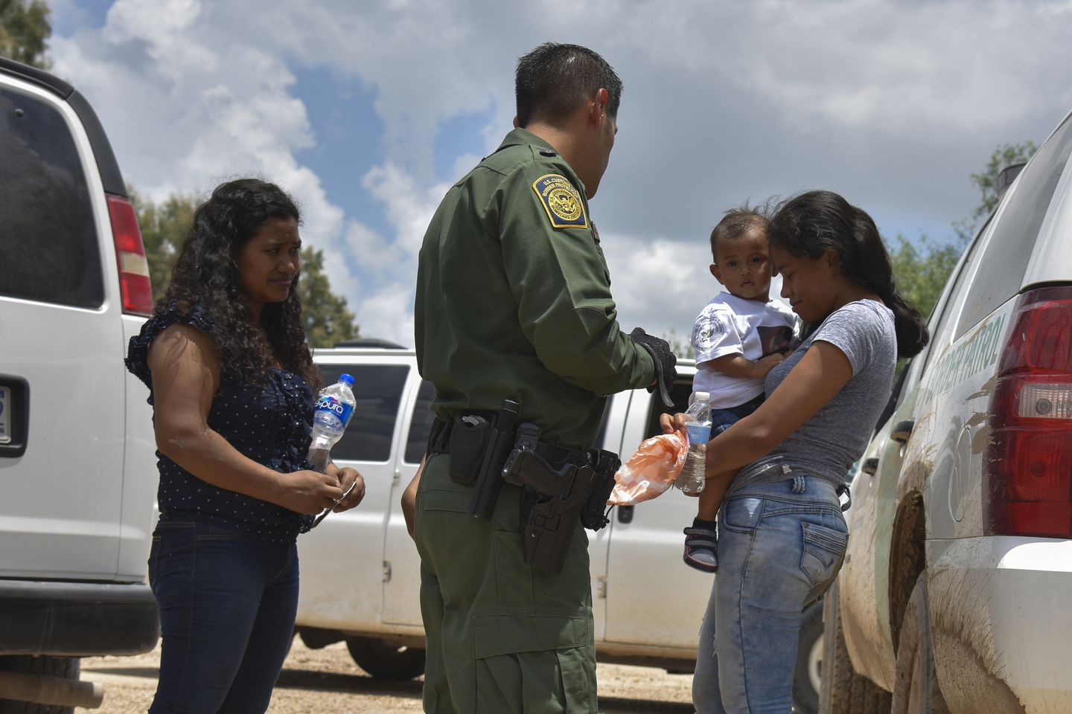
Two young mothers from Honduras and their children are detained by U.S. Border Patrol in Granjeno, Tex., after rafting across the Rio Grande in June 2018. (Jahi Chikwendiu/The Washington Post)

By Maria Sacchetti Oct. 24, 2019 The Washington Post
https://www.washingtonpost.com/immigration/aclu-says-1500-more-migrant-children-were-taken-from-parents-by-trump-administration/2019/10/24/d014f818-f6aa-11e9-a285-882a8e386a96_story.html

The American Civil Liberties Union said Thursday that the Trump administration separated 1,556 more immigrant children from their parents at the U.S.-Mexico border than has previously been disclosed to the public.
The majority of the children were ages 12 and under, including more than 200 considered “tender age” because they were under 5 years old.
The ACLU said the Justice Department disclosed the final tally — which is in addition to the more than 2,700 children known to have been separated last year — hours before a federal court deadline to identify all children separated since mid-2017, the year President Trump took office.
U.S. District Judge Dana M. Sabraw in San Diego gave the Trump administration six months in April to disclose the names to the ACLU, which is trying to track down all the families and learn whether they have been reunited.
The ACLU said the children were taken from their parents and released from federal shelters sometime between July 1, 2017, and June 2018, when Sabraw, an appointee of President George W. Bush, ordered the administration to reunite the more than 2,700 children who were still in custody without their parents.

But Sabraw and ACLU lawyers did not know at that time that hundreds of other children had been taken from their parents and released from U.S. Health and Human Services shelters months earlier, including when DHS secretly piloted the separations in the Border Patrol’s El Paso sector. An HHS Office of Inspector General report in January disclosed that the administration may have separated more families than it revealed to the public.
The ACLU says the newest figures show that far more “tender age” children were separated from their parents than previously understood. Federal officials have already acknowledged that approximately 100 of the 2,700 separated children last year were under age 5.
AD
But the new list says an additional 207 children, including several infants, were also separated from their parents and then released to sponsors. Another 101 children on the new list were 5 years old.

ACLU lawyer Lee Gelernt said the Justice Department has been sending the names of separated families to them in batches and provided the last information Thursday. He said he is worried that parents have been deported without their children.
“These are the families we’re going to have to search for all over the world,” Gelernt said Thursday. “We’re still in the middle of trying to find them.”
Justice Department lawyers have said in court that most of the separated children have already been released to parents or guardians.
A Justice Department spokesman declined to comment Thursday and did not immediately respond to requests to confirm the ACLU’s figures.

The ACLU’s announcement follows months of speculation about the number of children separated from their families at the Mexican border under a policy that Democrats and some Republicans decried as inhumane and some Homeland Security officials came to regret.
The Department of Homeland Security and the Justice Department officially implemented the family separations from May 2018 to June 20, 2018, to discourage fast-rising numbers of families, particularly from Central America, from surrendering at the Mexican border and seeking asylum. The Trump administration said adults were traveling with children on purpose because legal limits on detaining minors made it easier to slip into the United States.
Under the policy, federal officials prosecuted parents in criminal courts for the misdemeanor offense of crossing the border illegally and then dispatched them to immigration detention or deported them. Their children were sent to HHS shelters across the United States, and the Trump administration did not have a plan to quickly reunite them.

Family separations remain one of the most significant debacles of the Trump administration, and officials are still debating it more than a year later. The acting homeland security secretary, Kevin McAleenan, who is expected to step down soon, said in a recent interview that the family separations “went too far.”
“When you see the impact in the six-week period on 2,500 or so families and understand the emotional pain for those children, it’s not worth it,” he said in the interview. “It’s the one part of this whole thing that I couldn’t ever be part of again.”
Former homeland security secretary Kirstjen Nielsen told “PBS NewsHour” on Tuesday that she didn’t regret “enforcing the law” but was sorry for the prolonged separations.
“What I regret is that that information flow and coordination to quickly reunite the families was clearly not in place,” she said.

