- 4 Jun 2014 The New York Times By FRANCES ROBLES

Wave of Minors on Their Own Rush to Cross Southwest Border
ZoomBookmarkPrintListen
SAN PEDRO SULA, Honduras — After a decade apart, 13-yearold Robin Tulio was finally heading to the border to be with his mother. A maid, living illegally in Baltimore, she had decided the time was right to smuggle her son into the United States.
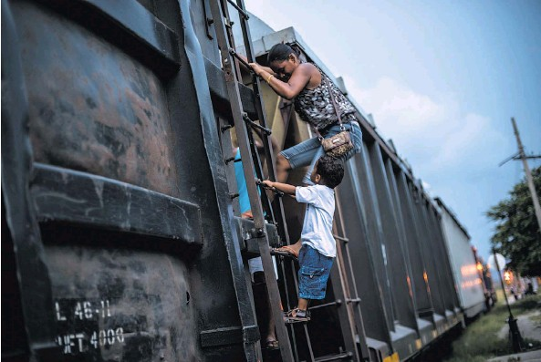
A migrant family in Tenosique, Mexico, climbed a northbound train stopped at a station. They said they were just practicing, preparing for a future trip.
Like so many others across Central America, Robin said his mother believed that the Obama administration had quietly changed its policy regarding unaccompanied minors and that if he made it across, he would have a better shot at staying.
She hired a smuggler, but Robin didn’t make it.
“It’s too hard,” he said after being caught in Mexico recently and sent home to Honduras. But his aborted journey helps explain why there has been a rush of migration of unaccompanied minors so severe that the United Nations declared it a humanitarian crisis akin to refugees’ fleeing war.
Since Oct. 1, a record 47,017 unaccompanied children have been apprehended at the southwest United States border, most traveling from Central America, part of a larger wave that includes some youngsters accompanied by their parents and some traveling alone.
Many say they are going because they believe that the United States treats migrant children traveling alone and women with their children more leniently than adult illegal immigrants with no children.
The Obama administration says the primary cause of the influx of children is rising crime and ailing economies in Central America, not policy changes in the United States.
To deal with the surge, the administration on Monday used a California naval base to house recently apprehended minors and ordered the federal emergency administrator to develop a plan of action.
“We have heard sort of rumors and reports, or suggestions, that the increase may be in response to the perception that children would be allowed to stay or that immigration reform would in some way benefit these children,” said Cecilia Muñoz, the director of the White House Domestic Policy Council, in a conference call with reporters on Monday. “It seems to be quite clear that what is driving this is what’s happening in their home countries.”
Officials said that recently arrived children would not benefit from the immigration bill passed by the Senate last year or from Deferred Action for Childhood Arrivals, a program that lets minors who meet certain criteria avoid deportation.
But even as the government moves to confront the situation, children, parents, immigration officials, lawyers and activists interviewed say that there has been a subtle shift in the way the United States treats minors.
That perception has inspired parents who have not seen their children for years to hire socalled coyotes, guides often associated with organized crime, to bring them north. It has prompted other parents to make the trip with toddlers in tow, something rarely seen before in the region.
“If you make it, they take you to a shelter and take care of you and let you have permission to stay,” Robin said after he stepped off a bus on a Thursday night with eight others caught on their way north. “When you appeal your case, if you say you want to study, they support you.”
In San Pedro Sula, in northern Honduras, a group of women and their children were huddled in a bus terminal earlier in the week, ready to begin a multiweek journey to Mexico and beyond.
“The passage is easier with the kids, and this way we’re not dumping them with relatives,” said Arelys Sánchez, who was traveling with two young daughters. “I think with them, it’s easier for them to let you stay.”
While the Obama administration has moved aggressively to deport adults, it has in fact expelled far fewer children than in the past. Largely because of a 2008 federal law aimed at protecting trafficked children, the administration in 2013 deported one-fifth the number of Central American children as were expelled in 2008, according to federal government statistics.
Ana Solorzano, an immigration official who tends to deportees in El Salvador, said that as the number of deportees flown by air to El Salvador from the United States started to drop, the number of people returned by land from Mexico started to rise. Of the 325 Salvadoran children who were deported last year, only 22 came from the United States, she said.
“They have not publicly recognized a change in public policy, but we see it,” Ms. Solorzano said.
Central Americans, she said, were left with the sense that the United States had “opened its doors” to women and children.
As more of those children were released from federal shelters and the number placed with parents or in foster care soared, other parents noticed. Those parents were encouraged by the opportunities children were being given to fight their cases in court — even if they were ultimately unlikely to succeed.
“It’s a massive Catch-22,” said Wendy Young, president of Kids in Need of Defense, an organization that matches unaccompanied minors with volunteer lawyers. “The problem here is that the system is broken. It’s going to implode.”
One federal judge slammed the Department of Homeland Security for “completing a criminal conspiracy” by placing a recently smuggled child with the undocumented immigrant parent who had hired the smugglers.
Experts say it is the dual dynamics of crime at home and perceived leniency across the border that have inspired many in Central America to risk the trip.
The United Nations has consistently listed Honduras, for example, as the country with the highest murder rate in the world. Its latest report said Honduras had 90.4 killings per 100,000 residents, nearly three times the rate a decade ago. In El Salvador, that number is 41.
Elizabeth Kennedy, a Fulbright scholar who is studying Salvadoran youth migration, said 60 percent of the 326 students she had interviewed cited gangs and crime as the reason they were leaving.
“A large number are forcibly recruited by gangs,” Ms. Kennedy said. “Most kids lived in areas that are controlled by one or both of the gangs.”
In Honduras, the authorities are receiving more buses filled with a larger number of juvenile deportees, and they are increasingly younger and often girls.
As gang violence here worsens and word gets out that the children who made it to the other side were reunited with long-lost parents with the blessing of United States immigration authorities, more and more youngsters are making the treacherous journey.
Maynor Dubón, 17, tried to cross the border last year. But he, too, was caught and wound up at Casa Alianza, a children’s shelter in Tegucigalpa, the Honduran capital, for a year.
“You really don’t know what moment you’re going to be killed,” he said of life in Honduras. “The gangs say things like, ‘You work for me now.’ They asked me to join, and I said, ‘Let me think about it for a few days,’ so I left. It’s like being in hell.”
A member of his immediate family was murdered at the family’s front door this year, so he is using the barber skills he learned at Casa Alianza to save money to try again. He must leave, he said, before he turns 18 in September.
Government officials say they are at a loss, because they cannot prohibit the children’s departure, but they worry what such an exodus will mean for the nation’s future.
“The governments have to do something; we can’t continue like this. These children are our future,” said Felipe Morales, executive director of the Honduran federal children’s services agency. “This is a tragedy.”

