- 24 Jan 2018 The New York Times By ALAN BLINDER and DANIEL VICTOR

SCHOOL GUNFIRE EVERY OTHER DAY
ZoomBookmarkPrintListen
Kentucky Attack Is No. 11 in 2018. It’s January.
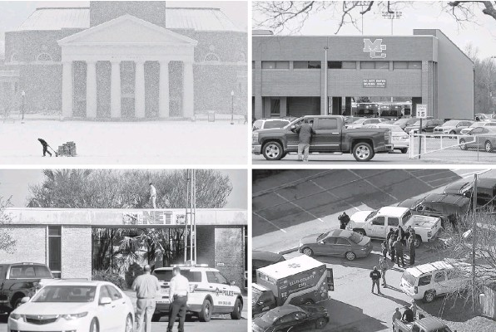
Clockwise from top left: Wake Forest University in Winston-Salem, N.C.; Marshall County High School in Benton, Ky.; Italy High School in Italy, Tex.; and the Net Charter School in New Orleans have all had shootings on school grounds in recent days.
ATLANTA — On Tuesday, it was a high school in small-town Kentucky. On Monday, a school cafeteria outside Dallas and a charter school parking lot in New Orleans. And before that, a school bus in Iowa, a college campus in Southern California, a high school in Seattle.
Gunfire ringing out in American schools used to be rare, and shocking. Now it seems to happen all the time.
The scene in Benton, Ky., on Tuesday was the worst so far in 2018: Two 15-year-old students were killed and 18 more people were injured. But it was one of at least 11 shootings on school property recorded since Jan. 1, and roughly the 50th of the academic year.
Researchers and gun control advocates say that since 2013, they have logged school shootings at a rate of about one a week.
“We have absolutely become numb to these kinds of shootings, and I think that will continue,” said Katherine W. Schweit, a former senior F.B.I. official and the co-author of a study of 160 active shooting incidents in the United States.
Some of the shootings at schools this year were suicides that injured no one else; some did not result in any injuries at all. But in the years since the massacres at Columbine High School in Colorado, Virginia Tech and Sandy Hook Elementary School in Newtown, Conn., gun safety advocates say, all school shootings seem to have lost some of their capacity to shock.
Shannon Watts, the founder of Moms Demand Action, a gun safety group, said that was because in 2012 in Newtown, “20 first graders and six educators were slaughtered in an elementary school.”
“The news cycles are so short right now in America, and there’s a lot going on,” she said. “But you would think that shootings in American schools would be able to clear away some of that clutter.”
Gov. Matt Bevin of Kentucky said the gunman who opened fire Tuesday morning at Marshall County High School in Benton, near the western tip of the state was a 15-year-old student. The authorities said the student entered the school just before 8 a.m., fired shots that struck 14 people, and set off a panicked flight in which five more were hurt.
One girl who was shot, Bailey Nicole Holt, died at the scene; a boy, Preston Ryan Cope, died of his injuries at a hospital.
Bryson Conkwright, a junior at the school, said he was talking with a friend on Tuesday when he spotted the gunman.
“It took me a second to process it,” Mr. Conkwright, 17, said in an interview. “One of my best friends got shot in the face, and then another one of my best friends was shot in the shoulder.”
The suspect, a 15-year-old who was not immediately identified, was taken into custody in “a nonviolent apprehension,” Mr. Bevin said, and officials said he would be charged with two counts of murder and several counts of attempted murder. But the authorities had not yet decided whether to charge the suspect, who was armed with a pistol, as a juvenile or as an adult.
Of the 18 people injured, five remained in critical condition, law enforcement officials said on Tuesday night.
“This is something that has struck in the heart of Kentucky,” Lt. Michael B. Webb of Kentucky State Police said at a news conference. “It’s not far away, it’s here.”
Not for the first time. The region was scarred about two decades ago by a deadly school shooting in West Paducah, about a 40-minute drive away. Three people were killed when a student opened fire into a prayer circle, and five more were injured.
Benton is a small town about 200 miles southwest of Louisville, and its high school serves students from all over Marshall County, which has a population of about 31,000.
About a mile from the high school, a large American flag flew at half-staff over a Ponderosa Steakhouse on Tuesday night. Taylor McCuiston, 21, a manager at the restaurant who graduated from Marshall County High School, was working when the shooting occurred down the road.
“It was very scary because, like, 90 percent of the staff that works here goes to that school,” she said. “So for the first hour we were just scrambling trying to make sure they were all O.K. and accounted for.”
The town of Italy, Tex., about 45 miles south of Dallas, is not any bigger than Benton. On Monday, a 15-year-old girl there was hospitalized after she was shot by a 16year-old classmate, according to local news reports. That suspect, a boy, was taken into custody by the Ellis County Sheriff’s Department. The authorities said on Tuesday that the victim was recovering.
The F.B.I. study that Ms. Schweit helped write examined active shooter episodes in the United States between 2000 and 2013. It found that nearly onequarter of them occurred in educational environments, and they were on the rise.
In the first half of the study period, federal officials counted 16 active shooter incidents in educational settings, meaning instances of a person “actively engaged in killing or attempting to kill people in a confined and populated area.” In the second half, the number rose to 23. (Many, but not all, of the school shootings tallied by advocates so far this year meet that definition.)
“Any time there’s a school shooting, it’s more gut-wrenching, and I think we have a tendency to react in a more visceral way,” Ms. Schweit said in an interview on Tuesday. “But I really don’t think as a whole, in society, we’re taking shootings more seriously than we were before — and that’s wrong.”
Even so, jarred and fearful school administrators across the country have been placing greater emphasis on preparing for the possibility of a shooting. According to a report issued by the Government Accountability Office in March 2016, 19 states were requiring individual schools to have plans for how to deal with an active shooter. Only 12 states required schools to conduct drills, but two-thirds of school districts reported that they had staged active shooter exercises.
School safety experts say steps like the drills are crucial, if imperfect, safeguards.
“I think we’ve become somewhat desensitized to the fact that these things happened, and it takes a thing like Sandy Hook to bring us back to our senses,” said William Modzeleski, a consultant who formerly led the Department of Education’s Office of Safe and Drug Free Schools.
“My fear is that if you don’t hear about a school shooting for a while, educators move on to other things,” he said. “Principals are busy. Teachers are busy. Superintendents are busy.”
In Kentucky, lawmakers have grappled with how to address the risk of school shootings. Last year, state legislators considered, but did not pass, a bill that would have allowed people with concealedcarry permits to bring weapons on to public school campuses, where proponents argue they could be used to respond to active shooters. A similar bill, limited to college campuses and certain other government buildings, has been introduced this year. It was not immediately clear how the shooting in Benton might affect the debate.
But in Benton, “this is a wound that is going to take a long time to heal,” said Mr. Bevin, the governor, “and for some in this community, will never fully heal.”

