- 3 Jan 2015 The New York Times By JULIE TURKEWITZ

After a Spa Day, Looking Years Younger (O.K., They’re Only 7)
ZoomBookmarkPrintListen
AURORA, Colo. — It was a day out at the spa for Paige Ehresman and her closest friends. Manicures. Hairdos. Makeup. And some gossip — about second grade.
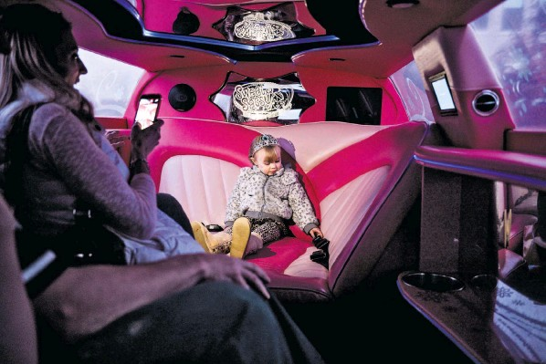
Jen Brown treated her daughter, Faith, to a manicure and a ride in a hot pink limousine at the Sweet and Sassy spa Aurora, Colo., to celebrate her third birthday.
The spa industry has begun to target children in a big way, going way beyond mother-daughter manicures. Adult spas are adding separate menus of services for girls, usually ages 4 to 14. In most major cities, there are now dedicated day spas for children, offering a range of massages, facials and other treatments for girls (and sometimes boys) too young to have had their first pimple.
“I feel like the best princess in the world,” said Paige, who celebrated her seventh birthday at Sweet and Sassy, a national chain of spas that boasts that its cosmetologists are specially trained to work with children. After the beauty treatments, Paige and her guests walked down a red carpet and disappeared into a hot pink limousine, which took the squealing children on a spin around the parking lot. One 6-year-old guest documented the revelry in a series of selfies.
These sanctuaries of luxury proudly pamper their charges, wrapping them in custom-size robes, suggesting oil rubs for heels worn rough by barefoot play, and lifting clients onto massage tables when they are too small to do it themselves. On the high end, the “kids’ treatments” menu at the Beverly Wilshire spa in Beverly Hills, Calif., charges $50 for a 15-minute “princess facial,” which includes “a facial cleanse and massage.” For the mass market, there is the $30 Orbeez Luxury Spa at Toys “R” Us, a toy that looks like a pedicure station in which girls can immerse their feet in tiny gelfilled balls.
At the party here in Aurora last month, Paige’s mother, Kari Ehresman, 33, said she was thrilled to be able to treat the girls to a day of playful pampering.
“They do deserve something special,” said Ms. Ehresman, who paid about $400 for the party. Paige and her 8-year-old sister, Makayla, had begged for beauty treatments, but Ms. Ehresman had found her own adult spa to be inappropriate for them.
“I don’t want them to feel that my saying ‘no’ means that I don’t love them,” she said.
The International Spa Association, which tracks industry trends, said that 25 percent of the country’s approximately 20,000 spas now offer services specifically for the under-13 set — up from 15 percent just four years ago. And half of all spas offer services for teenagers, up from a third over the same time period.
Some are new businesses focused exclusively on children, while others have expanded into the child market, offering kidfriendly music, banana-scented facials and an age-appropriate vocabulary — customers are “princesses” and toes are “pigglies.”
The spa association’s president, Lynne McNees, said it was good for girls to learn that beauty treatments can reduce stress and promote health. “It’s very similar to taking little kids to the dentist,” Ms. McNees said. “Let’s get them early, and get those really good habits.”
Most of the child-oriented spas make their money on birthday party packages, billing the events as sophisticated alternatives to a day of pizza and SkeeBall at the local Chuck E. Cheese. At one New York-area chain, Seriously Spoiled Salon and Spa, parties cost $500 to $3,000, and options include a “bath-bakery” experience, with lotions that smell like edible treats. (Tag line: “Where the main ingredient is you.”)
Lisa Gadzinski, 48, and her sister opened Seriously Spoiled on Long Island in 2008. The business, based in Patchogue, N.Y., has not only weathered the recession, but thrived, expanding to two more locations. Several clients are single fathers, lost in the world of girl-care, who bring in their daughters, Ms. Gadzinski said.
“Don’t we all want to spoil our children?” she asked.
But in the debate over modern parenting, the answer is not always yes.
“Oh my God,” said Christine Carter, a sociologist and the author of “Raising Happiness: 10 Simple Steps for More Joyful Kids and Happier Parents.” “What are we coming to? Spas for our children?” She cautioned parents against sending their offspring to places where they are told, “We’re going to treat you like a Kardashian.”
Madeline Levine, a child psychologist and author, called the child spa “the worst idea ever.”
At Sweet and Sassy in Aurora, though, parents and daughters had plenty of praise for the experience.
“I feel reeeeeeeally relaxed,” said Peyton Ruddell, who had just turned 10. She sat on a soft couch with soapy water bubbling at her heels while a cosmetologist, LiShall Michel, 47, clipped her toenails.
Peyton’s mother, Love Ruddell, 37, is a mechanic at the Denver Zoo who wears steel-toed boots and gloves to work, but also wears her fingernails long, manicured and painted a saucy red. She said she tried to teach her daughter that “you can be beautiful and tough.”
“This is honoring the feminine,” Ms. Ruddell added.
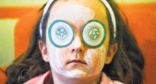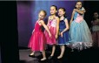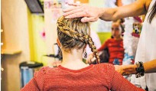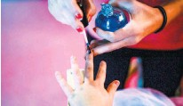
Nearby, Ken and Jen Brown raved about the manicure given to their toddler, Faith, 3, as a birthday treat. As Faith scooted her diapered rear out of her seat, Mr. Brown, 41, explained that they had arranged for her to take a ride in the spa’s limousine. And after that? “Well,” he said somewhat sheepishly, “we want to get her potty trained.”

