How Syria's civil war morphed into a struggle among global powers
Jim Michaels , USA TODAY March 14, 2017
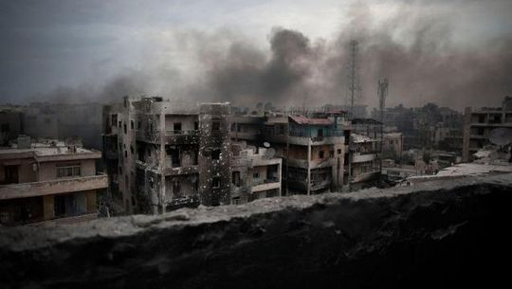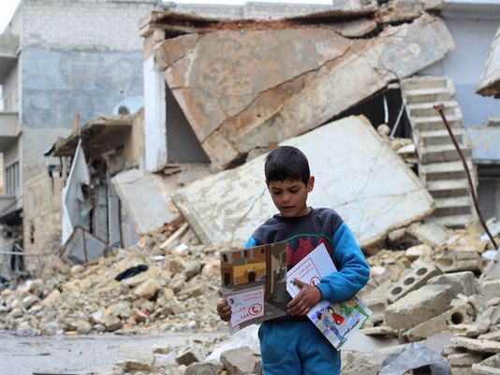
A child carries manuals distributed by UNICEF volunteers in the area following an informative session on identifying and reporting an unexploded object, at Al- Sakhoor neighborhood, east Aleppo, Syria.

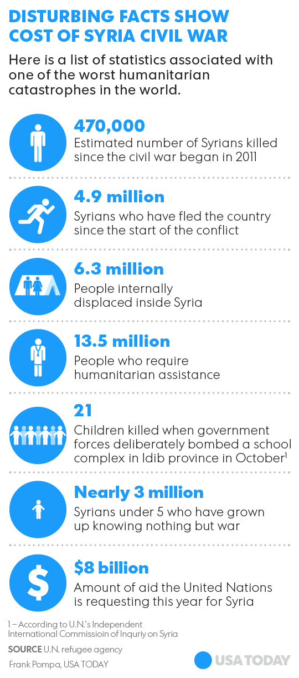
WASHINGTON — Syria's civil war began six years ago this week as a popular revolt against the brutal regime of President Bashar Assad.
Now a domestic uprising that has left an estimated 500,000 dead and millions homeless has morphed into a global war, sucking major powers into a conflict growing more volatile by the day.
The United States, Russia, Turkey and Iran — as well as foreign terrorists — have joined the fray with an array of forces, often with conflicting objectives. Overhead, the airspace is crowded with Russian and coalition aircraft, sometimes flying within sight of one another, as they pursue separate air campaigns.
In the shadows, Saudi Arabia and other countries in the Middle East have secretly backed armed fighters to overthrow Assad.
Rivalries and alliances are constantly shifting. “It's the most complicated environment and situation I've been in in my life,” said Army Lt. Gen. Stephen Townsend, the commander of coalition forces in Iraq and Syria.
Here is how one country's civil war turned into an international crisis:
THE START
The powder keg was lit in March 2011, when a group of boys were tortured by Assad’s agents for having written graffiti supporting the Arab Spring, a string of popular uprisings against autocratic regimes throughout the Arab world.
Thousands protested the boys' treatment, and the regime responded by killing dozens. Revolts against Assad, a member of the minority Alawite sect, began to spread, as some of his officers defected to opposition forces.
The Obama administration called for Assad to step down because of his brutal crackdown against dissidents, but it did not support the rebels at a time when it could have made a difference, said Mustafa Alani, director of national security for the Gulf Research Center in Geneva. “There was no clear decisive attitude from the Obama administration.”
Iran and Russia, by contrast, did not hesitate to throw support behind their long-time ally, Assad. Even so, the rebellion spread, and Assad lost control of large swaths of territory, particularly in the north.
ISIS IS BORN
The growing chaos attracted terrorists, including remnants of al-Qaeda in Iraq. An al-Qaeda offshoot that called itself the Islamic State, ISIL or ISIS grew in power as it battled Assad’s forces.
By 2014, the Islamic State began seizing terrain, including Raqqa and the oil region Deir ez-Zor. ISIS emerged as the most powerful of the forces battling Assad.
Later that year, the militant group launched a lightning strike into Iraq, capturing Mosul, the country’s second-largest city, and nearly made it to the outskirts of Baghdad. The attack caught Iraq and the rest of the world by surprise.
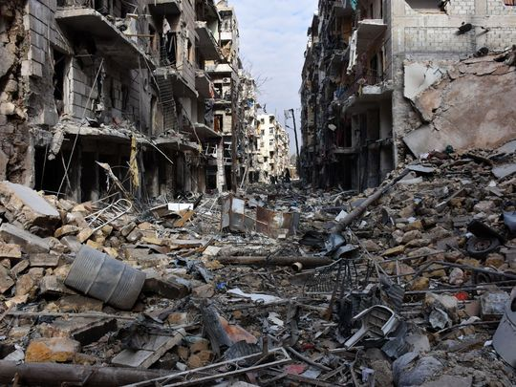
This file photo taken on December 7, 2016 shows general view of destruction in the al-Shaar neighborhood after government forces took control of the area in the eastern part of Aleppo.
U.S. FORCES ENTER
In August 2014, the United States responded with a bombing campaign against Islamic State targets in Iraq to blunt the militants' expansion. A month later, U.S. warplanes began striking targets in Syria, where the militants were headquartered.
Today, 5,000 U.S. troops are in Iraq to train and advise Iraqi forces. Another 500 Americans in Syria support a coalition of 45,000 Arab and Kurdish forces battling the Islamic State.
Airstrikes by a U.S.-led coalition have helped local ground forces drive ISIS out of a number of towns in northeastern Syria and are now intensifying efforts on Raqqa, the militants' headquarters.
RUSSIA, IRAN SAVE ASSAD
As the Islamic State has lost ground, Assad has strengthened his position. Assad appeared to be on the verge of defeat until Russia entered the battle in September 2015.
When the Russians first started bombing, Assad was losing territory. “The Russian intervention stopped the potential collapse of the regime and it led to a not insignificant recapture of territory,” said Chris Chivvis, associate director of the international security and defense policy center at Rand Corp.
While Russia dropped bombs, Iran provided critical ground forces that included Hezbollah, an Iranian-backed militia based in Lebanon.

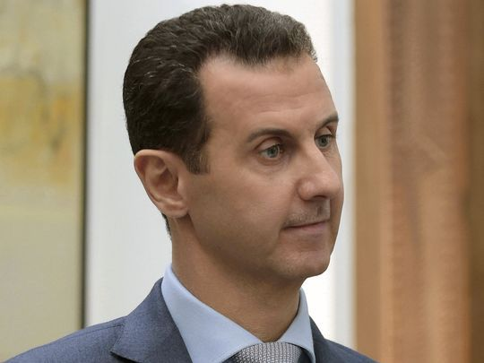
Syrian President Bashar Assad speaks during an interview with Yahoo News in Damascus, Syria, on Feb. 10, 2017. Assad said, there are "definitely" terrorists among the millions of Syrians seeking refuge in the West.
Last year, Russian-backed Syrian forces seized Aleppo, once the country’s largest city and a rebel stronghold. That battle was a major victory for Assad, and a huge loss for the prospect that a moderate opposition would come to power.
“That really marked the destruction of the last bastion of acceptable opposition groups in northern Syria,” said Christopher Kozak, an analyst at the Institute for the Study of War.
Today, most of the remaining opposition to Assad is made up of radical groups, including the Islamic State and al-Qaeda affiliates.
TURKS VS. KURDS
Turkey, once one of Assad’s fiercest opponents and a key U.S. ally in the region, is increasingly focused on what it sees as a greater threat: Kurdish fighters who may try to seize parts of Syria, Iraq and Turkey for an independent enclave.
The Kurds, who have tenacious ground forces, have been one of America’s most reliable partners against the Islamic State. When Iraq’s army was still in disarray, it was the Kurds who were holding out against the militants' onslaught.
With U.S. help, the Kurds have rolled up successes in much of northeast Syria, along the Turkish border. But their battlefield prowess worries the Turkish government that they will unite with Kurdish separatist groups inside Turkey.
Turkish Prime Minister Binali Yildirim said the United States would damage its relations with Turkey if it allows the Kurds to participate in the offensive to oust ISIS from Raqqa.
Coalition commander Townsend said the U.S. military is discussing with Turkey and the Kurds how both can help in the Raqqa campaign.
BATTLEFIELD GETS SMALLER
As the Islamic State loses territory, the potential for mishaps among the foreign forces grows, raising worries that a mistake could lead to a wider war. Last month, for example, Russian aircraft accidentally struck U.S.-backed Syrian forces near Manbij, a town near the Turkish border. U.S. advisers were nearby but not hurt.
Last September U.S. aircraft mistakenly targeted Syrian regime forces in Deir el-Zour, killing dozens. The Pentagon said it was a series of errors that led the U.S. military to believe they were targeting the Islamic State.
Sorting out all the forces on the ground is getting more difficult, said Gen. Herbert Carlisle, head of Air Combat Command. "As we continue to squeeze ISIS and continue to take more territory away from them, it becomes more complex."

