Journey to school photos
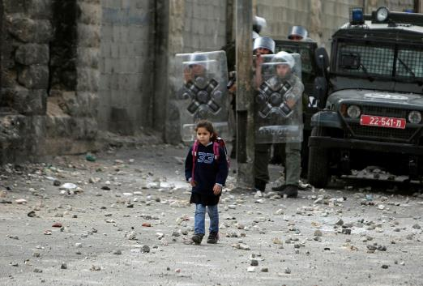

#18 The journey to school
A Palestinian schoolgirl walks past border police officers on her way home from school in the Shuafat refugee camp in the West Bank. March 16, 2010.

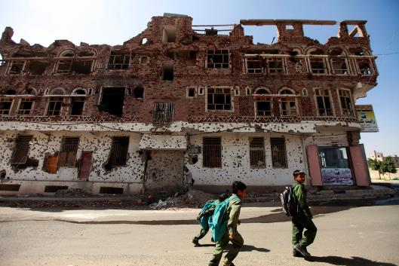

# 17 The journey to school
Boys on their way to school walk past a building damaged during protests and clashes in 2011 in Sanaa, December 17, 2013.
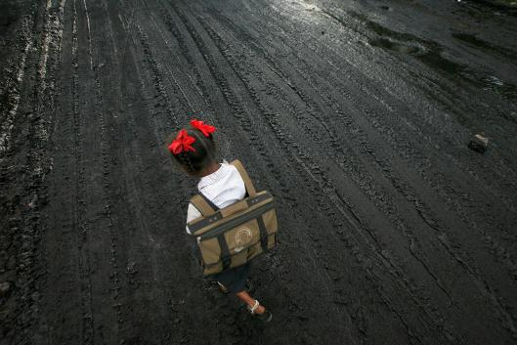

#16 The journey to school
A school girl walks on a road covered with oil and soot at an industrial area in Mumbai December 3, 2009.

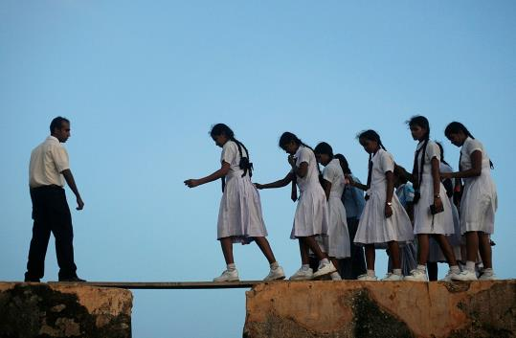

#15 The journey to school
School girls walk across a plank on the walls of the 16th century Galle fort July 8, 2009.

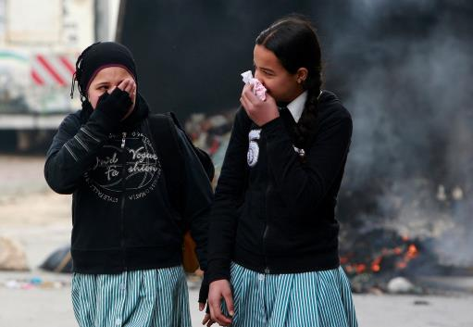

#14 The journey to school
Palestinian school girls walk past a burning garbage bin after stone-throwing youths were dispersed with tear gas by troops in the city of Hebron February 28, 2010.
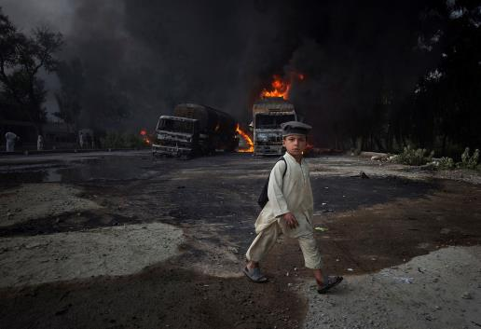

#13 The journey to school
A school boy, carrying a backpack, walks past burning fuel tankers along the GT road in Nowshera, located in Khyber-Pakhtunkhwa Province. October 7, 2010.

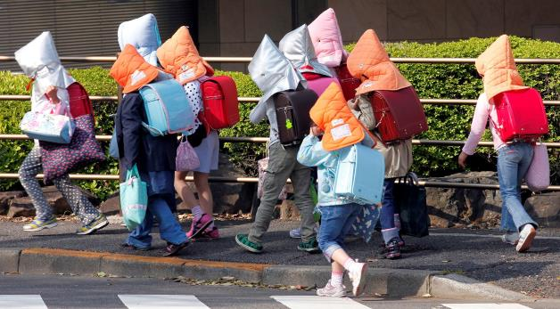

#12 The journey to school
Elementary schoolchildren wear protective headgear as they walk to school in Tokyo April 25, 2011. Some schools in Tokyo have asked their students to wear the protective headgear on their way to school.
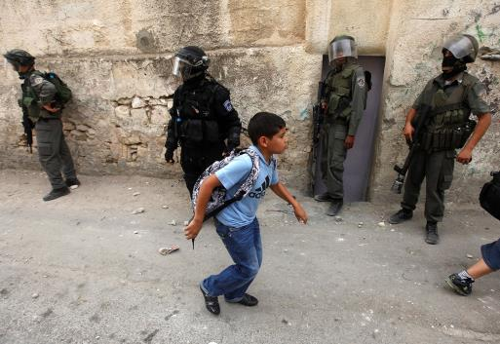

#11 The journey to school
A Palestinian school boy walks past border police during clashes with Palestinian stone throwers in the neighborhood of Silwan, September 22, 2010.
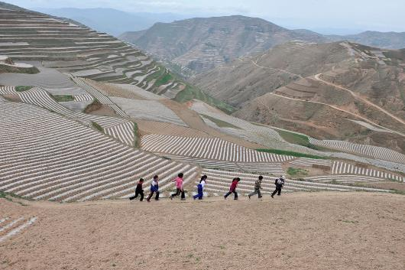

#10 The journey to school
Children walk along a road to their school after having their lunch at home in Min county, Gansu province June 1, 2011. The rural primary school, consisting of five teachers and 102 pupils, is located on a mountain measuring more than 2,000 meters (6,562 ft) high.
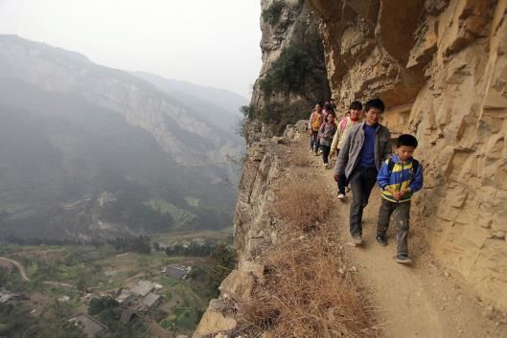

# 9 The journey to school
Xu Liangfan, 37, escorts students on a cliff path as they make their way to Banpo Primary School in Shengji county, Bijie city in Guizhou province March 12, 2013. Xu, who started working at the school last year, is the headmaster of the school and teaches mathematics and gym class.
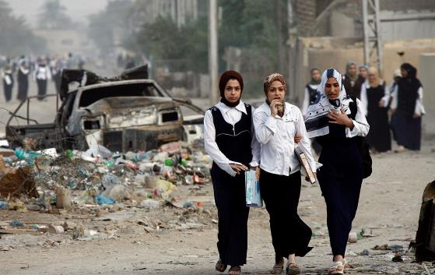

# 8 The journey to school
Schoolgirls walk in the Muhalla 832 Mechanik neighborhood in Baghdad November 12, 2007.
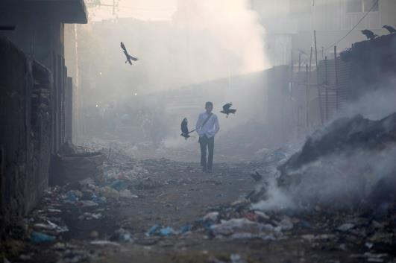

#7 The journey to school
A boy walks through an alley littered with the pile of smoldering waste, while heading to school during early hours of the morning in Karachi December 5, 2013.
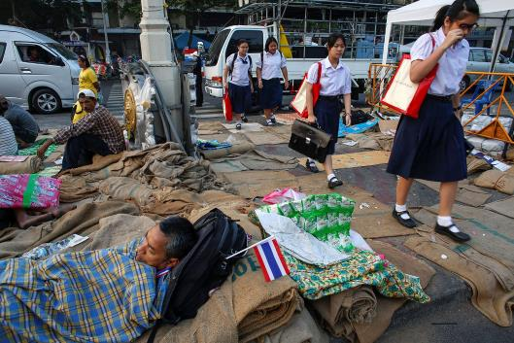

#6 The journey to school
School children walk past anti-government protesters lying on the ground at Democracy Monument in Bangkok December 11, 2013.
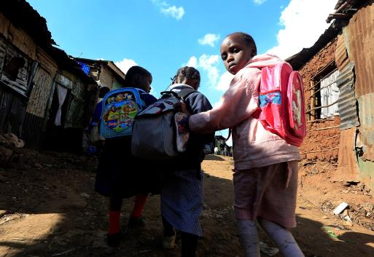

#5 The journey to school
Girls walk through a street as they return from school at the Kibera slum in Nairobi May 19, 2014.

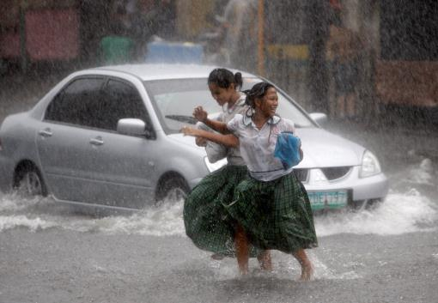

#4 The journey to school
Students walk across a flooded street during a heavy downpour which brought traffic in parts of Manila to a standstill September 10, 2008.
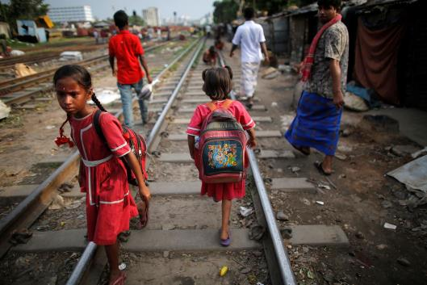

#3 The journey to school
Children returning from school walk along a railway track in Dhaka May 29, 2014.
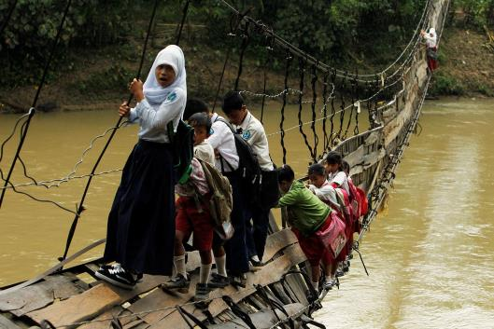

#2 The journey to school
Students hold on to the side steel bars of a collapsed bridge as they cross a river to get to school at Sanghiang Tanjung village in Lebak regency, near Banten village. January 19, 2012.

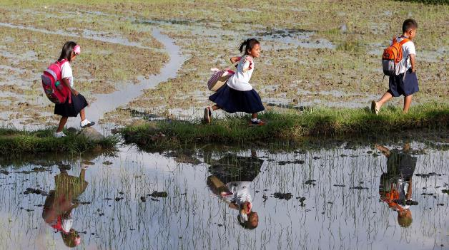

#1 The journey to school
Grade school pupils are reflected in the water as they walk between rice paddy fields, on their way home after attending classes in Mogpog, Marinduque, August 19, 2014. The students said they walk for more than two kilometers, including walking between rice paddy fields, from Monday to Friday to go to school and back home.

