Why India's brick kiln workers 'live like slaves'

http://www.bbc.com/news/world-asia-india-25556965
By Humphrey Hawksley BBC News, Andhra Pradesh
- 2 January 2014
- From the section India
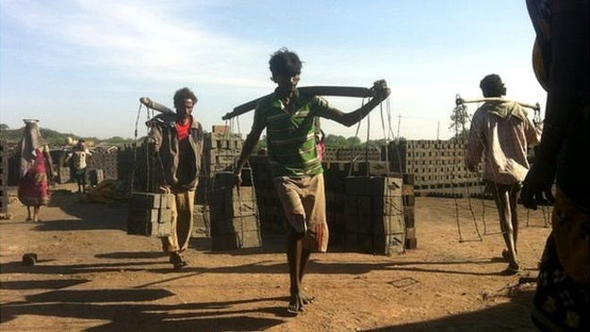Image caption Tens of thousands of families travel, mostly from the state of Orissa, to work in the brick kilns of Andhra Pradesh
Just outside of the southern Indian city of Hyderabad, by country roads in a flat green landscape, smoke rises off huge furnaces.
The heat hardens mud clay into the bricks that are making modern India.
Close by the air is acrid with coal soot, catching in the throat.
Like a scene from a long-gone age, men and women walk in single file up and down steps as if climbing a pyramid. They strain under a load, balanced in yoke-like hods, to deliver freshly moulded bricks to the furnace.
Down below, knee deep in water, their clothes ragged, workers hack at clay in a wet pit.
"The work is hard standing in the water, lifting the bricks," says Gurdha Maji, 35, as he packs mud into a brick mould and levels it off.
"We make 1,500 bricks a day. Only after six months will we get released."

'Against the law'
Nearby, there is a mound of coal. Woman and children squat at the edge. Most are barefoot. With ungloved fingers a woman holds down a piece of coal and smashes it with a hammer. Two children, barely four years old, their faces smeared black, break coal by hitting pieces against each other.
"All of this is against the law," says Aeshalla Krishna, a labour activist with the human rights group Prayas.
"This is against the minimum wage act of 1948, the bonded labour act of 1976, the interstate migrant workers act of 1979. Child labour. Sexual harassment. Physical abuse. It's all happening. Every day."
The bricks are used to build offices, factories and call centres, the cityscapes of a booming economic miracle, and more and more, these buildings are used by multi-national companies with a global reach.
Yet, Mr Krishna says he doesn't know of any bricks made under working conditions that would be acceptable under international standards.
The six-month season is now beginning when tens of thousands of families travel, mostly from the state of Orissa to work in the brick kilns of Andhra Pradesh.
Jump media player
Media player help
Out of media player. Press enter to return or tab to continue.
Media captionHumphrey Hawksley reports from the Indian city of Hyderabad
Among many reports of abuses, labour contractors last week were accused of cutting off the hands of two workers who tried to leave their jobs.
The brick kilns we visited comprised the most poverty-wracked communities of India.
Children were everywhere. There was no safety equipment. Stories of illness, withheld wages and other issues were common place.
"They work 12 to 18 hours a day, pregnant women, children, adolescent girls," says Mr Krishna. "Their diet is poor. There is no good water. They live like slaves."
The situation has been like this for decades, if not centuries. Until recently, it was widely accepted as something that would improve slowly over time. Campaigners say there's been little sense of urgency.
But in 2011, the United Nations and the Organisation for Economic Co-operation and Development (OECD) combined forces to introduce new guidelines for multinational companies operating in countries like India.
These companies now have a direct responsibility to check on human rights abuses anywhere in their supply chains.

'Game changer'
"It's a real game changer," says Tyler Gillard, the OECD's legal adviser.
"Any alleged abuses of human rights associated with the production of materials such as bricks and directly linked to a company's operations, products or services is a serious issue."
Britain has set up a National Contact Point for alleged abuses and this year made changes to its Companies Act to require companies to include human rights issues in their annual reports, from 1 October.
"We would expect any member to take very seriously the evidence of human rights abuses that are related to their business whether directly or indirectly," says Peter McAllister, director of Ethical Trading Initiative whose members include multinationals.
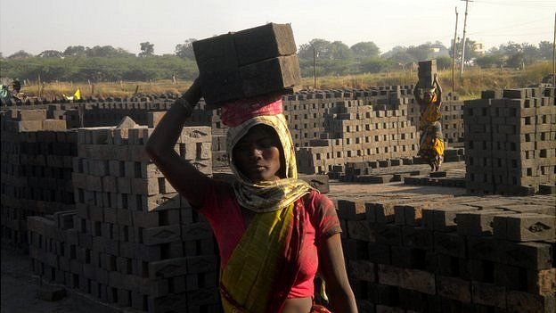Image caption Many women and children work at the kilns for '12-18 hours a day', say activists
And an international alliance of trade unions, Union Solidarity International, is launching a campaign - Blood Bricks - with the aim of forcing companies to carry out checks.

'Epidemic'
"The scale of forced and child labour in the brick kilns of India is of epidemic proportions," says UK Andrew Brady. "Simply put cheap bricks means cheap office buildings on the back of blood bricks and slave labour."
The Indian government insists it is on top the issue, providing housing, clean water and schools in the kilns around Hyderabad.
"The labour market is very conducive for multinationals," says Dr A Ashok, labour commissioner for Andhra Pradesh.
"We have taken action against brick kiln owners who have tried to exploit workers. There is no bonded labour and the minimum wage is paid. If there are some pockets here and there, they need to be rectified."
In squalid mud hut that's used for accommodation, we find Madhiri Mallik. She's five years old. The only clothing she wears is a pair of shorts.
Mr Krishna discovers that she came from the state of Orissa with her parents, Gurubhol and Amar, and her two year old brother, Vishnu.
Mr Krishna crouches down to check her eyes. "She is suffering from an eye problem because of the smoke. See how the eye is white. The haemoglobin is very low. She has a headache from the smoking bricks and her stomach is bad because of the water."
Regardless of what governments or human rights activists say, under the new trade guidelines it is up to each company to establish facts on the ground.
If they find cases in their supply chains like little Madhiri, they must take steps to try to help her.

