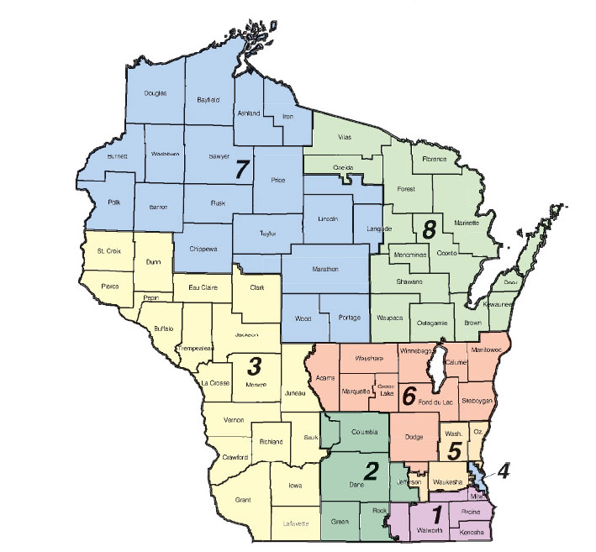
Wisconsin Congressional Districts – US House of Representatives

