- 21 Sep 2017 The New York Times
- By JULIE TURKEWITZ Doris Burke and Alain Delaquérière

Young Victims of Drug Crisis
ZoomBookmarkPrintListen
Young children found dead after consuming an adult’s drugs.
Toddlers and infants are being found unconscious or dead after accidentally consuming heroin, oxycodone and other opioids. When Penny Mae Cormani died in Utah, her family sang Mormon hymns — “Be Still My Soul” — and lowered her small coffin into the earth. The latest victim of a drug epidemic that is now taking 60,000 lives a year, Penny was just 1.
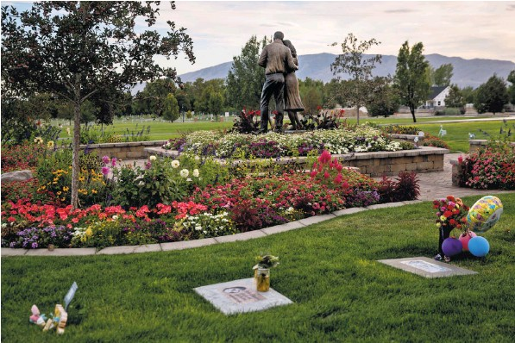
The infant section of the Lehi City Cemetery in Utah, where Penny Mae Cormani, a 1-year-old who died in 2015 after ingesting a dose of heroin, is buried.
Increasingly, parents and the police are encountering toddlers and young children unconscious or dead after consuming an adult’s opioids.
At the children’s hospital in Dayton, Ohio, accidental ingestions have more than doubled, to some 200 intoxications a year, with tiny bodies found laced by drugs like fentanyl. In Milwaukee, eight children have died of opioid poisoning since late 2015, all from legal substances like methadone and oxycodone. In Salt Lake City, one emergency doctor recently revived four overdosing toddlers in a night, a phenomenon she called both new and alarming.
“It’s a cancer,” said Mauria Leydsman, Penny’s grandmother, of the nation’s opioid problem, “with tendrils that are going everywhere.”
While these deaths represent a small fraction of the epidemic’s toll, they are an indication of how deeply the American addiction crisis has cut.
And communities from Appalachia to the Rocky Mountains and beyond are feeling its effects at all ages. In August, in the latest sign of the direness of the situation, President Trump said he would declare the opioid crisis a national emergency, a move that could allow cities and states to access federal disaster relief funds.
Eighty-seven children died of opioid intoxication in 2015, according to the Centers for Disease Control and Prevention, up from just 16 in 1999. By comparison, gunshot wounds kill four or five times as many children each year.
But at hospitals like Primary Children’s in Utah, drug overdoses now outstrip gun injuries among young people.
“There are no pill parties happening in preschools,” said Dr. Jennifer Plumb, the emergency doctor who recently treated four opioid-sick toddlers in a night. “These kids aren’t making a choice because they are trying to get high on a substance. It’s that the pills are everywhere.”
Unlike infants born with addiction, these children are coming across drugs in the days and years after birth.
In Philadelphia this summer, a 9month-old rolled onto a needle while in bed with her father. Kyleeh Isabella Mazaba, 20 months, died after drinking methadone left in a water bottle in the family van. James Lionel Vessell Jr., 2, swallowed oxycodone pills he found in a purse on his mother’s bed. And in early August, Kentucky officials treated an infant and three emergency responders believed to have been sickened by carfentanil-laced heroin that traveled through the air.
Often, emergency responders attempt to revive children with Narcan, an overdose reversal drug that works on small bodies as well as large ones.
Then come the questions for investigators. How did the substance get there? How did the child find it? Can this be stopped?
Sometimes officials charge caretakers with neglect or manslaughter. In one case this year, the authorities accused a couple of child endangerment after they admitted to rubbing Suboxone on their daughter’s gums, an attempt to hide the fact that she was born with an addiction.
But often the details go undiscovered, with witnesses too young to offer their own accounts.
Penny Mae Cormani was born Nov. 12, 2014, to Cassandra Leydsman and Casey Cormani, both mired in addiction. A year later, while the three of them were staying with another couple, Penny ingested enough heroin to kill a grown man.
Ms. Leydsman, the grandmother, said she believes Penny was scooting around on the floor during breakfast and found a bit of heroin, eating it like any child would. The official record is silent on exactly how the infant found the substance. But Penny’s parents pleaded guilty to third-degree felonies — Cassandra to child abuse homicide and Casey to attempted manslaughter — and went to prison.
Cassandra Leydsman is likely to serve 36 months.
Ms. Leydsman, 68, is a devout Mormon who raised five children with her husband, a retired pharmaceuticals manager. She traced her daughter’s addiction back more than a decade, to a car accident that prompted a doctor to prescribe OxyContin.
This led to a pill addiction that led to a heroin addiction that ultimately ended in Penny’s death. The family buried Penny in a baby cemetery south of Salt Lake City. In prison, Cassandra is receiving drug treatment.
“She knows she’s responsible,” Ms. Leydsman said of her daughter. “And it’s a terrible burden to go around knowing you’re responsible for the death of your child.”
In Utah, most opioid overdoses at the state’s only children’s hospital involve buprenorphine, oxycodone, methadone and hydrocodone.
In a state of three million people, pharmacists fill some 7,200 opioid prescriptions a day, according to 2015 data. Curious toddlers, Dr. Plumb said, are finding mom’s Suboxone strip, grandpa’s OxyContin.
In Montgomery County, Ohio, which includes Dayton, the story is different. Drug peddlers have flooded the community with fentanyl, a legal synthetic used for extreme pain, and powerful analogues like carfentanil, a substance 5,000 times stronger than heroin.
Inhaling, touching or ingesting a carfentanil dose smaller than a few grains of salt can be lethal. Dr. Kelly Liker, the medical director for child advocacy at Dayton Children’s Hospital, attributes a growing number of child overdoses to the rise of these substances.
In September of last year, Lee L. Hayes, 2, died in Montgomery County of fentanyl intoxication. In April, Nathan L. Wylie, 13, died of similar poisoning. And in May, Mari’onna Allen, 1, fatally overdosed in her grandmother’s home on Dayton’s East Fifth Street.
“It’s a disgrace that kids have to be subject to this,” said Mari’onna’s greatgrandmother, who declined to give her name. “They’re innocent, they don’t have a clue, and they don’t know drugs from candy.”

