AP FACT CHECK: Trump’s hype on migrants, illegal immigration
By HOPE YEN and COLLEEN LONG November 2, 2018
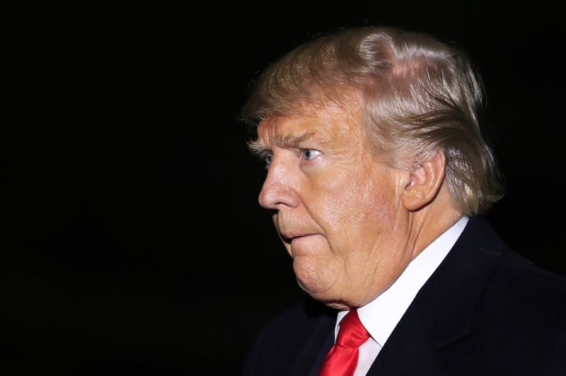
President Donald Trump arrives at the White House in Washington, Wednesday, Oct.
WASHINGTON (AP) — President Donald Trump is spreading misleading rhetoric about the nature of Central American migrants heading to the U.S. border and grossly inflating the number of immigrants living in the U.S. illegally.
In a speech Thursday, he suggested without evidence that the migrant caravans are full of hardened criminals; in fact, they are mostly poor people with few belongings who are fleeing gang violence.
In stressing that his administration will not allow a “catch and release” policy, Trump also claimed this week that 25 million to 30 million immigrants now live in the country illegally because previous administrations had “released” immigrants in the U.S. after they had been caught crossing the border as they awaited immigration hearings.
He’s wrong. Independent estimates put the number of people in the U.S. illegally at less than half that amount.
A look at his various claims on immigration:
TRUMP: “At this very moment, large well-organized caravans of migrants are marching towards our southern border. Some people call it an invasion. ...These are tough people in many cases; a lot of young men, strong men and a lot of men that maybe we don’t want in our country. ...This isn’t an innocent group of people. It’s a large number of people that are tough. They have injured, they have attacked.” — immigration speech Thursday.
THE FACTS: He suggests without evidence that people in the caravans are, by and large, dangerous, hardened criminals.
The migrants in the caravans are mostly from Honduras, where it started, as well as El Salvador and Guatemala. Overall, they are poor, carrying the belongings that fit into a knapsack and fleeing gang violence or poverty.
It might be true there are some criminals mixed in with the throngs, given the sheer number of migrants. Trump did not substantiate his claim that members of the MS-13 gang, in particular, are among them.
Some migrants in one of the caravans clashed with Mexican police at the Mexico-Guatemala border, hurling stones and other objects as they tried to cross the international bridge. One migrant died; it’s not clear how it happened. Caravan leaders said they had expelled a number of troublemakers from the procession, exhibiting some self-policing. Ultimately, most entered Guatemala — and later, Mexico — by illegally bypassing immigration checkpoints.
The caravan otherwise has been overwhelmingly peaceful, receiving applause and donated food from residents of the towns they pass. Mexican police have not tried again to stop them.
The Department of Homeland Security issued a fact sheet stating that “over 270 individuals along the caravan route have criminal histories, including known gang membership.” But it did not specify how it had arrived at that number.
___
TRUMP: “President Obama separated the children from parents and nobody complained. When we continued the exact same law, the country went crazy.” — immigration speech Thursday.
THE FACTS: Actually, President Barack Obama did not do the same thing as a matter of policy.
While it’s true the underlying laws were the same, the Trump administration mandated anyone caught crossing the border illegally was to be criminally prosecuted. That policy meant adults were taken to court for criminal proceedings, and their children were separated and sent into the care of the Health and Human Services Department, which is tasked with caring for unaccompanied migrant children. The so-called zero tolerance policy remains in effect, but Trump signed an executive order June 20 that stopped separations.
Jeh Johnson, Obama’s homeland security secretary, recently told NPR there may have been unusual or emergency circumstances when children were taken from parents, but there was no such policy.
___
TRUMP: “Asylum is not a program for those living in poverty.” — speech Thursday.
THE FACTS: He’s largely right. Poverty may play a role in the complex decision process granting asylum, but the status is reserved for people who have a justifiable fear of persecution in their own country based on factors such as their race, religion or political views. According to the Homeland Security Department, about 20 percent of claimants are granted asylum. Currently, there is a backlog of about 700,000 cases, and it can take years for claims to get resolved.
___
TRUMP: “We’re not doing releases. What’s been happening over years is they would come in, release them, and they would never show up for their trial. And we now have 25 or 30 million people in this country illegally, because of what’s been happening over many years.” — remarks Wednesday to reporters.
THE FACTS: It’s nowhere close to 25 million to 30 million, nor has the number increased much in recent years.
The nonpartisan Pew Research Center estimates there were about 11.3 million immigrants in the U.S. illegally in 2016, the most recent data available. That number is basically unchanged from 2009.
The number of such immigrants had reached a height of 12.2 million in 2007, representing about 4 percent of the U.S. population, before declining due in part to a weakening U.S. economy.
___
Find AP Fact Checks at http://apne.ws/2kbx8bd
Follow @APFactCheck on Twitter: https://twitter.com/APFactCheck

