- 16 Oct 2016 The New York Times By MICHAEL KIMMELMAN

Berlin, 1945; Grozny, 2000; Aleppo, 2016
ZoomBookmarkPrintListen

The destruction is so complete that it obliterates even a sense of time. At a glance, the video shot from a drone could show Berlin in 1945 or Grozny, 2000. Mass death erases all distinctions.
From page 2 The place is Aleppo, Syria, the Mashhad district, or what remains of it after recent attacks by Syrian government forces and their Russian allies. Toppled rooftop satellite dishes, choked by plaster dust, resemble wilted flowers. Figures move through the pulverized rubble but are hard to make out.
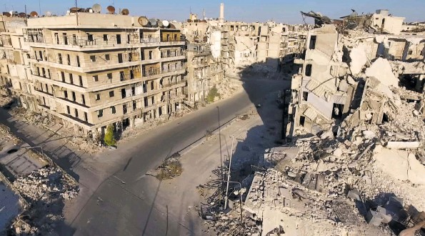VIA Above, damage in the Mashhad district, a rebel-held area of Aleppo, Syria, in an image from a video taken by a drone. Below, young siblings at Zaatari, a Syrian refugee camp in Jordan.
“Would you really feel any pity if one of those dots stopped moving forever?” Harry Lime asked on the Ferris wheel in “The Third Man,” the classic noir film set in postwar Vienna. This is drone footage, after all, shot from the same detached, superior perspective of the bombers who committed this atrocity in the name of fighting non-jihadist rebels. The video was made to document the devastation and bear witness, but it inevitably reduces people on the streets to Lime’s dots.
After the Second World War, Auschwitz survivors helped organize a display to memorialize the camp and came up with the archetypal piles of shoes and hair, prostheses and suitcases. The hope was to convey the scale of killing at a time when much of the world still didn’t know, or didn’t want to know, how many people the Nazis had murdered. Survivors declined to focus on stories of individual victims. They reckoned that nearly everyone in Europe had witnessed death up close and had their own stories to tell, whereas the industrial nature of murder was something else, something new, unfathomable and essential to record.
Today we are assaulted online, on television and in newspapers with big, senseless numbers: At least 140 killed in the Saudi-led bombing of a funeral in Yemen; hundreds slain by car bombs in Baghdad; thousands upon thousands slaughtered in Aleppo. The tallies blur together even while it can be nearly unbearable to glance at the photograph of Alan Kurdi, the dead 2year-old refugee on the Turkish beach, or the video of Omran Daqneesh, the stunned little boy from Aleppo, pulled from the ashes, sitting in the ambulance, wiping blood from his face.
Once seen, these images become impossible to forget. More than the specter of endless shelters and the staggering numbers of displaced people, what comes to mind whenever I read about the war are the dusty, hopeful faces of six small, barefoot siblings I photographed with my phone while standing outside their windblown tent in Zaatari, a Syrian refugee camp, just across the border in Jordan. I wonder how they are doing.
There are now some 65 million displaced people around the world, equivalent in number to the entire population of the United Kingdom or France. Refugees spend 17 years on average in camps. The children at that Syrian camp fled their home just ahead of the guns and rockets. I wonder what “home” will ever mean to them. To those more fortunate, it promises safety, family. The ruined landscape in the drone video, reminiscent of that earlier Russian military campaign in Grozny, had been a community of shops, noisy streets — and homes. Now so hard to decipher, these crumbling apartment houses were, until lately, particular to the people who filled them with children and mementos. With raised voices and the whispered exchanges of love and heartbreak. With music, prayers, friends, the smells of food cooking on the stove. With dreams of a better life.
This used to be a neighborhood, in other words. A neighborhood is more than an assortment of buildings and streets. It is life, shared and rooted in place, passed down through generations — nowhere more so than in an ancient city like Aleppo, where some years ago I was taken to the home of a man who lived on a street that bore his family name.
“How long has your family lived here?” I asked him. “On the street or in Aleppo?” he replied. Before I could answer, he told me: “On the street, 800 years. In Aleppo, 1,200.”
Communities incubate hope. Extinguishing this is the goal of mass murderers and tyrants.
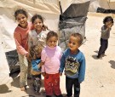
That is what the drone video shows.

