- 23 Oct 2016 The New York Times

Haunted by the Ones Left Behind
ZoomBookmarkPrintListen

They Took In a Refugee Family. But Families Don’t Have Borders. By JODI KANTOR and CATRIN EINHORN
“What’s happening now is something we never dreamed in Syria or Lebanon.” MOUHAMAD AL-HAJJ, a Syrian refugee now living in Toronto
Wissam al-Hajj, a Syrian refugee, woke up in the most comfortable home she had ever lived in, an apartment growing increasingly stuffed with toys for her four children. She realized she had slept far more soundly than usual. But when she remembered why, she grew irritated: Her husband, Mouhamad, had hidden the phone from her.
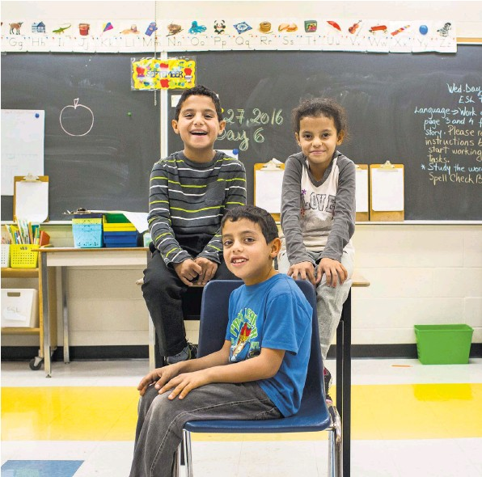
From left, Majed, Moutayam and Zahiya al-Hajj, children of Mouhamad and Wissam al-Hajj, are learning English at school in Canada.
As their older children competed for the first shower, Ms. Hajj recalled the argument from the night before. Her husband had been trying to spare her from an agonizing consequence of their move to Canada: the pleading messages from family members and friends across the Middle East.
“I’m only going to give it to you if you stop talking to them at night,” he had said to her.
“I’m going to start working and buy my own phone,” she had shot back, the threat hollow but deeply felt.
Seven months earlier, the couple had been catapulted to a new life. As many other nations were shunning refugees, a group of Canadian strangers had essentially adopted the family for a year, an effort repeated thousands of times across the country. In Lebanon, where the family had fled from Syria, the children used to work for a dollar a day and cry as they watched others board school buses. Now, attending school for the first time in their lives, they treated the morning like a race: poised to go, ready with new backpacks and insulated lunchboxes an hour before the bus arrived.
The family was living through the first refugee crisis in history in which people without countries or homes could communicate instantaneously with one another. Previous generations of refugees often ached for any information about relatives, but now messages zipped back and forth around the world on free apps. The joy of such regular communication came at a steep cost: constant updates on the misery of relatives left behind, intensifying worry and impeding progress for those trying to carve out a new life. The Hajjes’ phone pulsed with voice messages in Arabic:
Enjoy every sip of cold water, because I have none.
Your brother was jailed because his papers expired. He needs $900 to renew them or he will be arrested again.
Can you bring us to Canada?
The couple heard that last question as many as 20 times a day. If the messages arrived while Mr. Hajj was grocery shopping, he would blank on which items to buy, instead becoming lost in questions. The couple had just arrived in Canada with one piece of luggage and almost no money of their own, so what could they do? Which relative would they even try to help first — his brother or her brother, or one of the dozens of others?
Sometimes Mr. Hajj did not respond to the messages because he had no idea what to say. When he and his wife did reply, they left out some details of just how different their lives had become.
In Lebanon, which has been flooded with refugees, passers-by cursed the family’s relatives for being Syrian. In Canada, just the evening before, an older couple had approached the Hajjes in the park, asked, “Syrian?” and insisted on sharing their phone numbers in case they could do anything for the newcomers. As one of Ms. Hajj’s brothers was scrambling to find the money to stay out of jail, the Salvation Army gave the Hajjes a gift card for about the same amount, letting them refurnish their three-bedroom apartment overlooking lush foliage in Toronto.
(In an earlier article on the private sponsorship of refugees in Canada, the couple used part of their family name, Ahmed, because of safety concerns. They have since given permission to use their official surname, al-Hajj.)
After the children left for school, Mr. Hajj picked up his own new backpack and headed to English class. He was focused on moving forward, on seizing every opportunity he could. In Syria, he had been a farmer and shepherd. Now, at 36, he was finally learning to read and write, and in an entirely new language.
That morning, he was the star of his class. His nice-to-meet-yous made his teacher’s dangling earrings sway as she nodded approval, and he helped a Mandarin speaker who was struggling to fill out a work sheet. To his amazement, the English words he heard outside class were beginning to mean something. In the opaque lottery of the refugee system — this family goes here, that family stays there — many people ended up with diminished lives, but he and his children had better prospects than ever before. “What’s happening now is something we never dreamed in Syria or Lebanon,” he said.
Sometimes he was fatalistic about the messages from home; in black-humor moments, he commented that he and his wife should stop listening to them.
Ms. Hajj, however, often stayed up for much of the night to converse with relatives seven hours ahead, growing weepy and exhausted by dawn. Like many of the relatives, she had never learned to read or write, so they used WhatsApp to volley short voice recordings. Those messages felt like a lifeline, and the ones that were not harrowing were comforting: greetings for the Eid al-Adha holiday among her 16 half and full siblings, and a running whosebaby-is-cuter photo contest. Sometimes she woke her 10-year-old son, Majed, in the middle of the night for technical help.
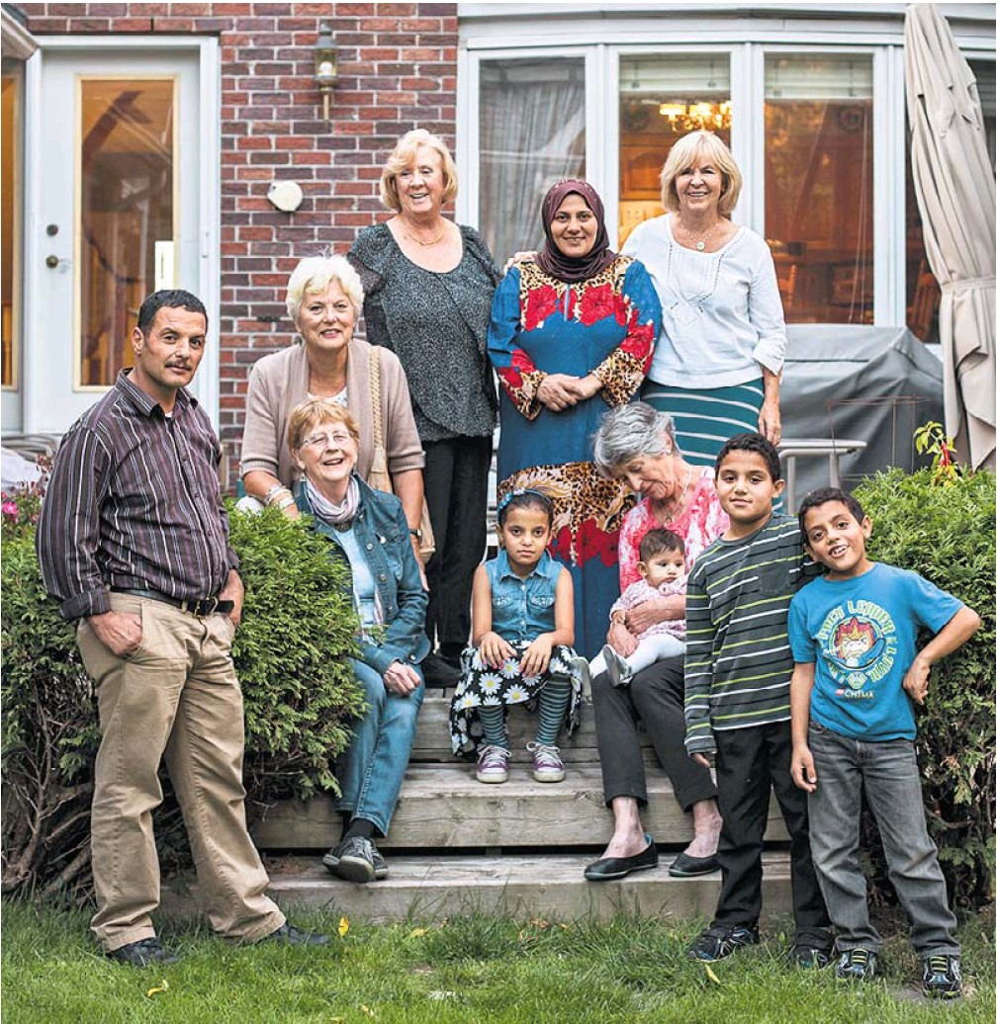
She was trying to embrace life in Canada, cheering during her children’s soccer matches and soaking up advice on tummy time and solid food for her 5-month-old, Julia. But her husband worried that the infusions of survivor’s guilt were preventing her from fully entering her new world. She often seemed more connected to the electronic constellation of relatives back home than to the Toronto streets she did not know and the English signs she could not decipher. When the sponsors tutored her in English, she often yawned through the lessons.
Now, alone with Julia, Ms. Hajj played another request that had just arrived, this one from a sister-in-law in Lebanon.
We just want to thank you in advance for anything you can do. We would be forever grateful to you if this happened.
The two women were close. Eman Khalaf, the voice on the phone, was married to Mouhamad’s younger brother Ali. The two couples had lived side by side in their village south of Aleppo, then in adjacent tents in a refugee camp in Lebanon. The day before, Mouhamad had told Ali that school was starting in Canada, and he had replied:
I envy you so much, your kids will visit us when they are doctors and engineers.
The brothers had dreamed of reuniting in Canada. Mouhamad had promised his younger brother that he would take up the cause with the sponsors who were resettling his family.
The grandmotherly group had become the Hajjes’ funders, chauffeurs, tutors and all-around tacticians. Julia had never been held by her real extended family; her parents’ new living room displayed photographs of her and her siblings with the sponsors’ grandchildren. The sponsors had found schools, doctors, clothes, summer programs and bikes for the children. When those first bikes were stolen, they got new ones. The weather was still sweltering, but they had already outfitted the older children with head-to-toe ice-skating gear. A few nights before, a fire alarm had woken the Hajjes, but because the sponsors had thought to explain what to do, they exited the apartment calmly.
Because of the care the sponsors took, Ms. Hajj said she had no worries about her immediate family’s future in Canada. She felt especially close to Peggy Karas, a former geography teacher whose slight air of sternness belied her generosity. Sometimes when she saw Ms. Karas at her door, the older Canadian woman straining a bit under the heavy bags of fruit and halal meat she had brought, Ms. Hajj’s eyes welled in gratitude. “I feel like Peggy is like my friend, my mom, my sister,” she said.
The Hajjes’ best hope for helping their relatives, they believed, lay with Ms. Karas and her partners, who could sponsor additional family members or find other Canadians to do so. Ms. Hajj had already blurted out requests for the sponsors to bring over her brother Ibrahim.
But her husband had not yet said a word to the sponsors about his own brother. He intended to, but his concern for his distraught wife stopped him: Perhaps she needed a relative more. “Maybe if someone from her family comes here, she will feel better,” he said.
Asking the sponsors about more than one relative seemed like too much. The Hajjes cringed at making requests of their patrons or doing anything that could seem like taking advantage. Even when Mr. Hajj’s father asked the couple for money, a humiliating request for the older man, they did not feel they could siphon from the allowances the sponsors had given them.
“They’re giving us all of this, with nothing in return, and we have to bother them with other requests as well?” Ms. Hajj asked.
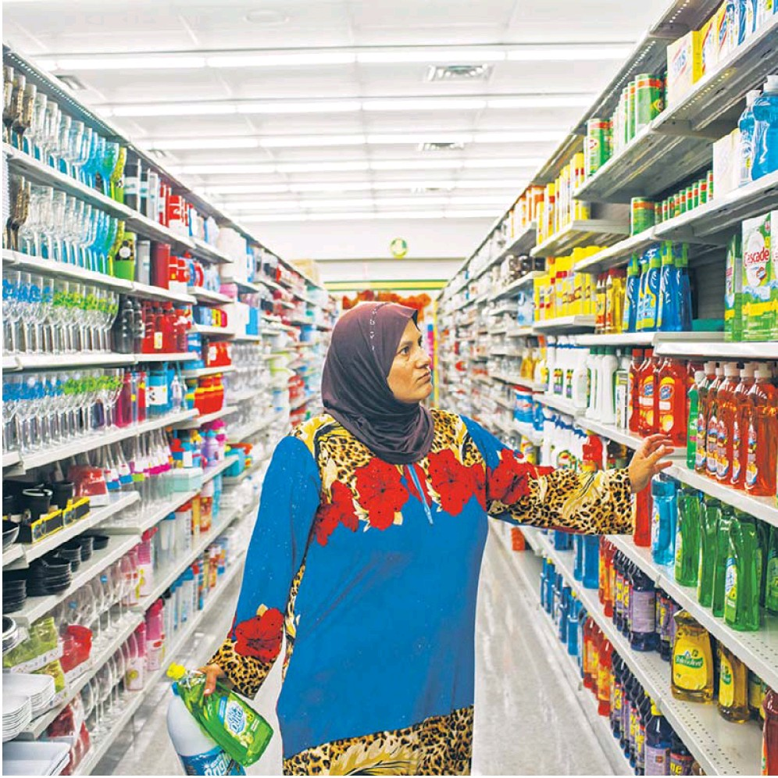
She had little idea that her inquiries, conveyed in gestures and broken English, were pushing the volunteers into conversations they had never anticipated. Something similar was happening all over Canada. Thousands formed groups to sponsor one family for one year, to give their time and money to initiate the new arrivals into Canadian life. But thanks in large part to cellphones and social media, Canadians with no prior connection to the Middle East were getting glimpses into the well of desperation that was the refugee crisis.
They found themselves confronting quandaries: When an infant relative in Jordan needed surgery her parents could not afford, should the sponsors reach into their pockets to pay? Was it better to invest everything in resettling one family or to spread the resources between two? Should the Canadians select which relatives to help, to spare the Syrian newcomers from choosing?
Even though they had already responded to the refugee crisis more generously than many people across the world, was it enough? Where did it stop?
Bar Elias, Lebanon Sept. 9, Morning
As Mouhamad al-Hajj was sleeping in his handsome new bed in Toronto, his brother Ali stood at a dusty crossroads halfway around the world, a few miles from the Syrian border. He was one of the millionplus refugees in Lebanon, another face in a cluster of laborers waiting all day at the intersection for a chance to work. Even if one of the trucks rumbling by stopped, work was not a sure thing. Sometimes the men would rush the vehicle, piling onto the back, and the strongest would force the others off, winning the job. Ali al-Hajj, 30, made it once every five or 10 days at best.
The youngest worker in the crowd was 13. Ali dreaded that his own children could be in that position one day. “I don’t care about money; all I care about is giving a proper education to my kids,” he said. He was counting on his brother in Canada for that chance.
The two used to stand at the intersection together, looking like a matched set with their skinny frames. They had lived in tandem since childhood. Mouhamad was the one who had spotted Eman as a potential wife for his younger brother. When the Hajjes lost their fourth child, shortly after birth, in Lebanon last year, the two brothers stood shoulder to shoulder to dig the tiny grave.

