Immigration crisis: Support grows among Wisconsin Democrats and Republicans for keeping children with parents
Bill Glauber and Craig Gilbert, Milwaukee Journal Sentinel Published June 21, 2018
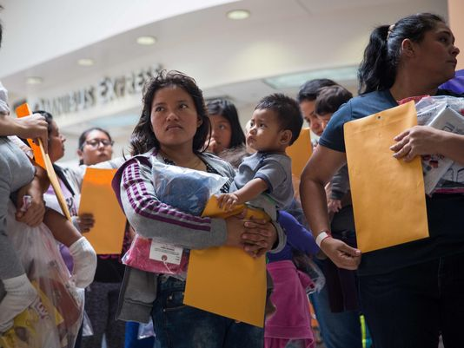
Immigrants wait to head to a nearby Catholic Charities relief center after being dropped off at a bus station shortly after release from detention.(Photo: Loren Elliott/Getty Images)
The crisis at America's southern border with Mexico has reached into the heart of Wisconsin politics.
The images of children separated from immigrant parents unleashed a torrent of outrage from Democrats, while Republicans have sought ways to tamp down the controversy.
President Donald Trump's signature Wednesday on an executive order to halt family separations may only be a temporary salve. Parents and children will now be detained together.
But the issue is not going away anytime soon, especially with the fate of more than 2,000 children already separated from their parents unclear.
“So apparently it’s OK to be a kid in a cage if you’re with your mom," said Rep. Mark Pocan, D-Wis.
"That’s about all he did. At least there is a recognition of part of the problem," said Pocan of Madison. "But publicly people get this so much more than the White House right now. People get that kids shouldn’t be separated from their parents."
Rep. Mike Gallagher of Green Bay who was at meeting at the White House Wednesday where Trump discussed immigration with GOP lawmakers, said he thought Congress still needed to legislate on the issue.
“It just not good to govern through executive order,” Gallagher said. "So we in Congress need to step up and fix it."
If Republicans and Democratic lawmakers in the state are united on anything right now, it's the need to find a permanent solution to ending the separation of immigrant families at the border.
Advocates say they are struggling to keep track of thousands of children who get lost in the federal system since the implementation of the Trump administration zero-tolerance policy.
In the Senate, Republican Ron Johnson has spearheaded a bill with 26 other GOP senators to keep immigrant families together.
“But the real issue at hand is a broader immigration issue," Johnson said in a statement. "We need to stop incentivizing people to come to this country illegally."
Meanwhile, Democratic U.S. Sen. Tammy Baldwin has joined every other Democratic senator backing a bill that halts the policy of separating families at the border.
"The Trump administration policy of separating families and traumatizing children is wrong and immoral," she said.
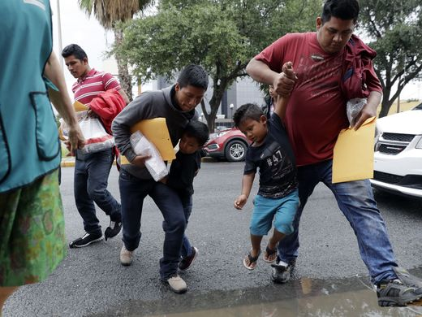
Young immigrants are lifted over a puddle as they arrive with their parents at the Catholic Charities RGV after they were processed and released by U.S. Customs and Border Protection.

The Republicans seeking to challenge Baldwin in the fall, Leah Vukmir and Kevin Nicholson, also said they backed legislation seeking to end the crisis.
Initially, Vukmir did not state opposition to the policy but later threw her support behind Johnson's legislation and favored Trump's executive order.

1st Congressional District
Democrats are trying to pick off the seat currently held by House Speaker Paul Ryan of Janesville and the fight over the issue has intensified.
Ryan opposes family separation and is trying to get a Republican compromise immigration bill through the House.
Democratic hopefuls Randy Bryce and Cathy Myers said that's not enough and have pilloried the Trump administration.
Bryce called for an end to a zero-tolerance policy at the border, reuniting families and abolishing ICE. "Bottom line — we need a real change," he said.
Myers said she was "sickened" by Trump's initial policy of separating families and called for "rebuilding a functioning legal immigration system."
Bryan Steil, a Janesville attorney and the front-runner in the GOP race, said: "We can keep families together while enforcing our immigration laws. This situation demonstrates the dysfunction of our federal government and just how broken our immigration system is. Congress and the administration need to address this immediately."

2nd Congressional District
Pocan, who doesn't face a challenger in the fall, was at the border in Texas with other Democratic lawmakers Sunday. They visited the point of entry at the Hidalgo bridge, the Border Patrol processing center at McAllen, and the former Walmart in Brownsville converted into a migrant children’s shelter.
A prominent Trump critic, Pocan said family separation was "the policy of one person in the United States."
"He is trying to do everything he can to try to force us to give him money for a wall," Pocan said.

3rd Congressional District
Rep. Ron Kind, a La Crosse Democrat, said in a Facebook post Wednesday that the immigration system is certainly in need of repair, but separating children from their parents is wrong.
Kind said that despite Trump’s claims, there is no law that requires this “inhumane action.”
Kind’s opponent, Republican candidate Steve Toft, a retired U.S. Army colonel, said he was stationed at Joint Base San Antonio is 2014 and saw more than 2,000 unaccompanied children housed away from their parents. Toft said the border needs to be monitored and the U.S. needs to enforce current immigraiton laws.
“If we had a secure border and people came in a legal fashion, we wouldn’t have to deal with illegal children,” Toft said.

4th Congressional District
Rep. Gwen Moore, a Milwaukee Democrat, "wholeheartedly rejects the policy of separating families at the border," and has advocated for community-based alternatives that are far less costly and more humane, said spokeswoman Libbie Wilcox.
An outspoken critic of Trump's hard-line immigration policies, Moore has co-sponsored resolutions aimed at ending the practice of separating families, expediting proceedings for detained minors and condemning the administration's zero-tolerance policy that ramped-up separations beginning in April.
Tim Rogers, who is running against fellow Republican Cindy Werner in the August primary, said he supports detaining refugees at the border while they are vetted to determine their eligibility for asylum. But he believes the families should be detained together.
"We need the border wall for sure, to stop this (migration)," Rogers said. "I support detention ... but we should keep them as a family unit until we exactly know why they're coming over."

5th Congressional District
Rep. James Sensenbrenner, a Republican of Menomonee Falls, said he was asked about the immigration policy by a constituent who was "horrified by the stories of children being separated from their parents and asked what can be done to stop it."
"I assured her that I, too, believe this situation is disgraceful and am distraught to see it occur," Sensenbrenner said in a Facebook post.
He called the immigration system "horribly broken," criticized the Obama administration's "catch and release" policy and said "there is no reason to separate children from their parents."
"I find this practice to be immoral," he wrote. "We are indeed a nation of laws, and we must enforce them. Our laws, however, must reflect the values of our nation, and this practice certainly does not represent who we are."
Jennifer Vipond, a GOP challenger to Sensenbrenner, said she opposed family separations. "A grandiose show of toughness is great when dealing with dictators or countries that steal intellectual property," she said in an email. "It is not so great when directed against refugees and babies."
Democratic challenger Tom Palzewicz criticized Sensenbrenner and the family separations.
"I am appalled by the current administration’s recent policy change that forces families apart," he said in a statement. "Forty-year incumbent Jim Sensenbrenner had remained completely silent on this issue until yesterday and still refuses to call out the Trump Administration for instituting this heinous policy in the first place."

6th Congressional District
Earlier this week, Republican Rep. Glenn Grothman of Glenbeulah released a statement that said one of his priorities "is to make sure we have an immigration system that promotes safety and fairness."
He said a good place to start to fix the immigration system "would be to address the shortage of family spaces in ICE shelters along the border and make sure they are properly funded.”
Grothman's Democratic challenger, Dan Kohl, said: "I believe this administration’s policy on border detentions is cruel and beneath the greatest country on earth. This isn’t a partisan issue. This is a human issue. As Americans, and as fathers and mothers, we cannot sit by and remain silent when children are torn from their parents’ arms and detained in cages."

7th Congressional District
Rep. Sean Duffy, a Wausau Republican, said in a statement that he plans to support legislation allowing children to stay with their parents when detained. He also called for strengthening the border and eliminating incentives for people to enter the country illegally, saying an insecure border has created a situation in which children are torn from their families.
Duffy’s potential Democratic challengers blamed the Trump administration for the crisis.
Margaret Engebretson, a Polk County attorney and military veteran, said the U.S. needs to work toward immigration reform that includes heightened border security and citizenship for people who have “been living in and contributing to our communities.”
Marshfield doctor Brian Ewert said, "The images of young children being forcibly separated from their parents pulls at our hearts."

8th Congressional District
Gallagher said Congress shouldn't rely on presidential executive orders and instead should do its job and pass legislation.
“You shouldn’t have to choose between keeping families together or catch and release," he said, adding, "I think there will be a legislative fix."
"Your only other option shouldn’t be to let people in this country that come illegally," he said.
Democratic challenger Beau Liegeois urged Congress to "pass a clean immigration bill that provides a pathway to citizenship for law-abiding undocumented immigrants, while giving the border patrol the tools they need to protect our borders such as increased staffing, electronic monitoring and surveillance tools."
Reporters Jonathan Anderson, Max Bayer, Haley Bemiller, Lee Bergquist, Annysa Johnson, James B. Nelson, Melissa Siegler and Mary Spicuzza contributed to this report.

