Hundreds of immigrant kids remain separated from parents
By Tal Kopan, CNN August 30, 2018

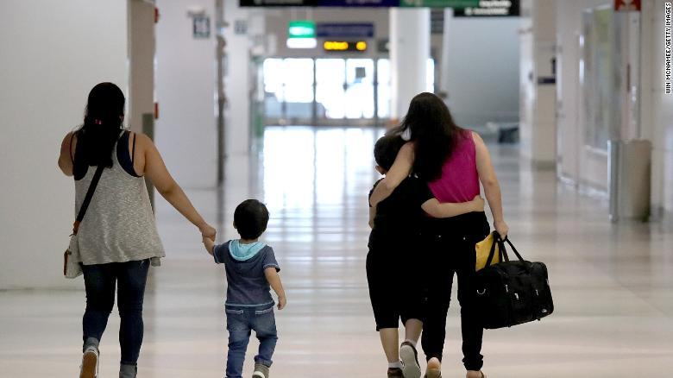
Hundreds of children separated from their parents at the US-Mexico border remain separated from them, including 497 in government custody, according to a new court filing Thursday.
The figure includes 22 children under the age of 5 still in government care. Six of those are 4 years old or younger whose parents were deported without them.
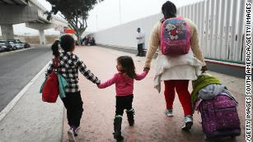

Hundreds of separated children not reunited amid slow progress
A total of 1,937 children have been reunified with parents, up only 14 from last week.
The court filing from the Justice Department and the American Civil Liberties Union case describes a slow and laborious process to try to connect the families that have been separated.
It remains unclear exactly how many parents were deported without their children, though it's in the hundreds. By the government's latest count, there are 322 deported parents who have children still in custody.

But the ACLU, which filed the lawsuit on behalf of separated parents, says the administration has previously given it a list of deported parents that includes 70 additional cases. The administration said, according to the ACLU, that some of the discrepancy is due to kids being released from care. It's not clear what will happen to those families. The ACLU said it intended to pursue the issue further with the administration -- including whether the government plans to reunite those families.
The government says it has contacted the vast majority of the deported parents, but the ACLU says that many of those parents have not yet been reached. Of the total deported parents the ACLU was alerted to, the network of law firms and nongovernmental organizations working on the effort has spoken with 279 thus far, the ACLU said.
Just over 40 have made it to the final step of the process: ACLU determining exactly what the parents and the kids each want to do about their reunification, making sure it lines up and communicating that to the administration.
Even reunifying those children who have agreed to go back to their home countries has proved difficult.
The problem is that there are two separate cases -- one that represents parents, and one that covers the children. Federal Judge Dana Sabraw has halted the deportation of children pending a case that argues they have their own rights to claim asylum in the US.
The administration attorneys say that many of the children want to be sent home and have agreed to leave voluntarily, but the attorneys representing the entire group of children have been slow to sign off on departures under the judge's order. The attorneys ask the judge to expedite the process so the kids can be sent back to their home countries to reunite with their parents.
The rest of the children who are separated either have parents who declined reunification or who pose some sort of safety risk, according to the government. A handful also were found upon further examination to not have been separated from a parent in the first place.
The judge will hold a status hearing in the case on Friday.
Earlier this summer, the judge set a July 26 deadline for reunifying all eligible families who were separated at the border. Deported parents have remained the most difficult group to reunite.

