India's tobacco girls

http://www.bbc.com/news/world-asia-india-18391652
- 12 June 2012
- From the section India
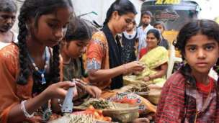Image caption Almost all beedi workers in Kadiri are young girls that work up to 14 hours a day
On World Day Against Child Labour, Davinder Kumar of Plan International investigates the plight of young girls engaged in making beedis - the traditional hand-rolled cigarettes - in the southern Indian state of Andhra Pradesh.
Five-year-old Aliya thinks it is some kind of a game she must soon master to be a winner.
From the time she wakes up and until she goes to bed, Aliya watches her mother and all the girls and women in her neighbourhood consumed in a frantic race.
They all make beedis, the traditional hand-rolled Indian cigarettes.
For each beedi, the roller painstakingly places tobacco inside a dried leaf sourced from a local ebony tree; tightly rolls and secures it with a thread; and then closes the tips using a sharp knife.
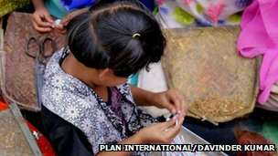Image caption Five-year-old Aliya has already begun training to roll beedis
Working between 10 and 14 hours a day, Aliya's mother and others must roll at least a 1,000 beedis each, to earn a paltry sum of less than $2 (£1.28) paid by the middleman.
The beedi manufacturers, however, make billions of dollars.
The rolled beedis are taken to the warehouses of large manufacturers where they are packaged and sold in the market for a much higher price.
The beedi is hugely popular and makes for nearly half of India's entire tobacco market.

Human robots
In Aliya's town of Kadiri in Andhra Pradesh alone, hundreds of families have for generations relied on beedi rolling as their only means of survival.
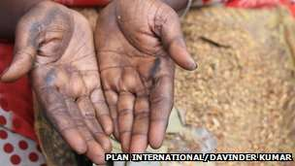Image caption The skin on the fingertips of the beedi-rollers gets thinner
The labyrinthine, congested lanes of the Kadiri slums are home to an assembly line of humans functioning like robots.
Young girls and women sit out in the open, rocking back and forth, appearing entranced.
Many have developed odd muscular motions as they push their work speed to the edge of human limits.
"The pressure to keep up with the speed and meet the target is so intense that many skip their meals and even avoid drinking water so they do not need to go to the toilet," says Shanu, a community volunteer.
Almost all beedi workers in Kadiri, like in the other beedi manufacturing areas of India, are female and a large number of them are young girls.

'Nimble fingers'
Aliya has already started her lessons and is practising rolling beedis using cuttings of plain paper.
"I want to roll beedis and give the money I earn to my mother," she says.
A study released nearly three years ago estimated that a shocking number of more than 1.7 million children worked in India's beedi rolling industry.
Children are knowingly engaged by manufacturers who believe that their nimble fingers are more adept at rolling cigarettes.
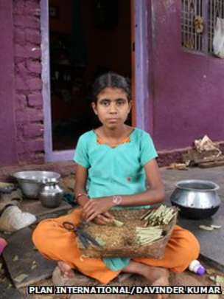Image caption Salma has jaundice but she still rolls 1,500 beedis a day
Under Indian law, beedi rolling is defined as hazardous work.
But there is a loophole which allows children, who assist their parents in their work, to be kept out of the purview of the law.
"Formally, it is the women who take the orders from the contractors. However, given the pressures these women face in terms of delivering, invariably children, mainly girls, get pulled into this to support their families in beedi rolling," says Anita Kumar of Plan India.
As part of its global campaign "Because I am Girl", the child rights' organisation has started a programme focused on the girl child labour in Andhra Pradesh, including girls involved in beedi making.
The project will impact 1,500 girls over three years.
"We are aiming to create a model by working with communities and the local government structures, ensuring that children are prevented from falling into this cycle of labour," Ms Kumar says.
From unhealthy living conditions to exploitative wages, slave-like working conditions and severe health consequences - the situation of beedi workers involves violation of their fundamental rights and freedoms on many levels.
A majority of the girls are pulled out of school by the time they complete primary school to support their families' incomes.
Youngest among four siblings, 11-year-old Salma dropped out of school last year.
"I wanted to continue going to school but we are very poor and have been struggling to pay the rent," she says as she struggles to draw a breath.
Salma is suffering from jaundice and is so frail she can barely sit straight.
Yet, she is tasked with rolling up to 1,500 beedis a day to support her family.
She is in dire need of medical attention, but visiting the local hospital means a day off work due to long queues and a day's wage in transport. Her parents cannot afford either.

'No protection'
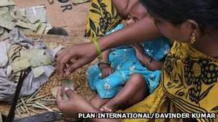Image caption The adverse health impact of beedi work is visible on all age groups
The adverse health impact on beedi workers is visible on all age groups.
Continuous beedi rolling leads to absorption of high doses of nicotine directly through the skin.
The skin on the children's fingertips begins to thin progressively, and by the time they reach their 40s they cannot roll cigarettes any more.
The worst thing for beedi workers is the feeling that there is no protection, no welfare, no state support.
In summer as the temperatures reach 45C, streets in Kadiri are engulfed in a stifling cloud of tobacco dust as infants play among heaps of tobacco leaves.
Covered in a pool of sweat, young girls roll beedis with their eyes transfixed on their tobacco tray.
Older women, who cannot roll any more, help with trimming the ebony leaves.
The work continues until late in the night just to secure the next day's meal and to keep a roof above the head.

