- 4 Dec 2017 The New York Times By ROD NORDLAND

Jailed With a Serial Killer, Beginning at Birth
ZoomBookmarkPrintListen
Young Afghan Girl Has Never Left Side of Mother in Prison
JALALABAD, Afghanistan — Meena got chickenpox, measles and the mumps in prison. She was born there, nursed there and weaned there. Now 11 years old, she has spent her entire life in prison and will probably spend the rest of her childhood there as well.
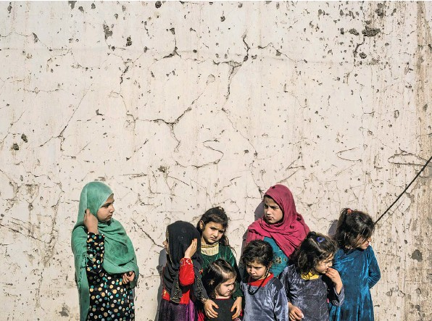
Meena, far left, with other children on Saturday at the women’s ring of the Nangarhar provincial prison in Jalalabad, Afghanistan.
The girl has never committed a crime, but her mother, Shirin Gul, is a convicted serial killer serving a life sentence, and under Afghan prison policy she can keep her daughter with her until she turns 18.
Meena was even conceived in prison, and has never been out, not even for a brief visit. She has never seen a television set, she said, and has no idea what the world outside the walls looks like.
Her plight is extreme, but not unique. In the women’s wing of the Nangarhar provincial prison here, she is one of 36 children jailed with their mothers, among 42 women in all. But none of the other children have spent such a long time in custody; most of their mothers’ sentences are much shorter.
Locking up small children with their mothers is a common practice in Afghanistan, especially when there are no other close relatives, or fathers are absent or estranged. Child advocates estimate that there are hundreds of imprisoned Afghan children whose only crime is having a convicted mother.
There is a program that runs orphanages for children whose mothers are imprisoned, but the women have to agree to let their sons and daughters be taken, and the program does not cover many areas of Afghanistan, including Jalalabad.
At Meena’s prison, the women’s cells are arranged around a spacious courtyard, shaded by mulberry trees, and the children have free rein of it. There is a set of rusting, homemade swings, monkey bars and slides that end in muddy puddles.
A schoolroom is in one of the cells, with a white board and a mixture of benches and chairs, seating 16 children at eight desks. A single teacher looks after three grades, first through third, an hour a day for each grade; at age 11, Meena has reached only the second grade.
When I met with Meena, she sat down, clutching a yellow plastic bag under her shawl. “My whole life has passed in this prison,” she said, during a tense interview in the women’s wing last month. “Yes, I wish I could go out. I want to leave here and live outside with my mother, but I won’t leave here without her.”
Meena was soft-spoken, composed and well-mannered, with a cherubic round face framed by a modestly drawn hijab. Her mother was chain-smoking, brash and outspoken, tattooed in a country where tattoos are considered irreligious, her head scarf askew to reveal henna-streaked hair.
“How do you think she feels?” Ms. Gul said, impatient at what she derided as stupid questions. “It’s a prison, how should she feel? A prison is a prison, even if it’s heaven.”
A question about why Ms. Gul would not let her daughter leave infuriated the mother even more. She launched into a diatribe against the Afghan president. “You, Mr. America, tell that blind man Ashraf Ghani, your puppet, your slave, tell him to get me out of here,” she said. “I didn’t commit any crime. My only fault is that I cooked food for my husband who committed a crime.”
The man she calls her husband, Rahmatullah (they were never legally married), was convicted along with her son, her brother-inlaw, an uncle and a nephew for their role in the murders and robberies of 27 Afghan men in 2001 to 2004. Afghan prosecutors said Ms. Gul was the ringleader.
Working as a prostitute, Ms. Gul brought home her customers, many of them taxi drivers, and served them drugged kebabs, after which her family members robbed, killed and then buried them in the yards of two family homes.
All six were sentenced to death, and the five men were hanged. Ms. Gul, however, got pregnant while on death row, so her own hanging was delayed. After she gave birth to Meena, her sentence was commuted to life in prison by the president at the time, Hamid Karzai, according to Lt. Col. Mohammad Asif, the head of the women’s cellblock here.
Ms. Gul first claimed that she had never confessed to the crimes, then said she had been tortured into confessing to them. Frustrated, she made clawing gestures across a table and hissed, “I’ll kill you. I’m going to come over there and take out your eyes.”
Meena touched her lightly on the shoulder to try to calm her down, put a forefinger to her lips and said, “Shh.” Her mother subsided, briefly.
The girl was still holding the yellow plastic bag; inside was a bundle wrapped in a carefully folded red and white kitchen towel.
“What’s in there, Meena?” I asked.
“Pictures of my father.”
She proudly unwrapped them to show them off. Meena and her mother rarely get visits, and never from family members or friends, all of whom are either dead or estranged. Part of the reason Meena is still behind bars is that she has no surviving relatives who would take her, even if her mother allowed it.
Or as Ms. Gul explained it: “I have many enemies. I wouldn’t trust anyone to take Meena outside.”
The photos were of Rahmatullah, whom Meena calls her father: portraits, snapshots on holiday, pictures of him with Ms. Gul.
Rahmatullah (who like many Afghans had only one name) was also convicted of killing Ms. Gul’s legal husband, a police colonel, when Ms. Gul and Rahmatullah were having an affair. The colonel’s body was among those found buried in the yards of the family homes in 2004. Rahmatullah was also a convicted pedophile and thief and reputedly a former Taliban commander.
What he almost certainly was not, however, was Meena’s biological father; the dates do not fit. He was already in jail when he implicated Ms. Gul in the murders, and they were in different prisons in different cities at the time of Meena’s conception. Afghan officials said that an unknown prison officer was Meena’s birth father, and officials accused Ms. Gul of deliberately getting pregnant to avoid the gallows.
Meena went through the photographs one after another, lingering over some, including two of Rahmatullah dead, after his hanging, in a burial shroud but with his face visible; it was not a pretty sight.
In a 2015 interview with The New York Times, Ms. Gul admitted that she and Rahmatullah had killed her husband together.
She denied it when I spoke to her. “It was all Rahmatullah’s fault,” Ms. Gul said. “I would not be here if it wasn’t for him. They should execute me, then Meena would have cried for one day, and it would be over. Instead I am crying every day; it’s a slow death, dying all the time.”
In her calmer moments, Ms. Gul had a simple, chilling message to convey: Meena deserves her freedom. But she won’t get it unless her mother does, too.
“Tell Ashraf Ghani that!” she demanded.
Children in jail is a scandal without an easy solution, advocates say. “When you didn’t commit a crime, you shouldn’t be punished for it, and those children did not commit any crimes,” said Bashir Ahmad Basharat, the director of the Child Protection Action Network, a quasi-governmental agency.
Keeping the children in prison is against both international norms and Afghan law, Mr. Basharat said, despite the practice being so widespread. “But it’s something where we don’t have other alternatives.”
The country’s approximately 30 women’s prisons have several hundred children accompanying their mothers, he said. The women’s wing at the Pul-e-Charkhi prison in Kabul now has 41 children who are younger than 5.
As Afghan prisons go, Nangarhar’s women’s facility appeared to be comparatively uncrowded and well maintained. The 36 children there on the day I visited ranged in age from three days to 11 years; Meena was the oldest.
The women and their children share 10 relatively large cells, with two double bunk beds each, so many of them sleep on mattresses on the floor. Only the compound as a whole was locked up, not the individual cells, so it did not appear prisonlike, aside from the huge steel gates to the outside and the coils of barbed wire atop two rows of surrounding double walls.
Meena sat through her mother’s tirades impassively, sometimes with a thin, sweet smile. She became more animated talking about her best friend, Salma, 10. She said their favorite pastime was playing with their dolls.
“Dolls?” her mother shrieked at an Afghan reporter. “This stupid person is asking about her dolls? These foreigners are only interested in childish things.”
Meena said she and Salma created their own dolls, named Mursal and Shakila, out of bits of cloth and string. “Both of them are girls,” she said.
This was too much for Ms. Gul to bear. “What you should do, Mr. America, is get her a TV. You’re my visitor, you came to talk to me. We don’t even have a TV. I should get ISIS to come and cut off your head.”
When it was time to say farewell, Meena shook hands with everyone politely, then went to the other end of the courtyard with Salma, arm in arm, still carrying her yellow plastic bag.
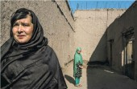
Ms. Gul, who had calmed down by then, shook hands politely as well, her gaze bold and challenging. “Give me some money,” she said.

