- 10 Mar 2018 The New York Times By COREY KILGANNON

Still Circling for a Spot
ZoomBookmarkPrintListen

More Students in Affluent Neighborhoods Are Driving Their Fancy Cars to School, Making Parking an Issue
GREAT NECK, N.Y. — The parking areas at John L. Miller-Great Neck North High School here on Long Island can sometimes resemble a luxury dealership — BMWs, Range Rovers and Mercedes-Benzes.
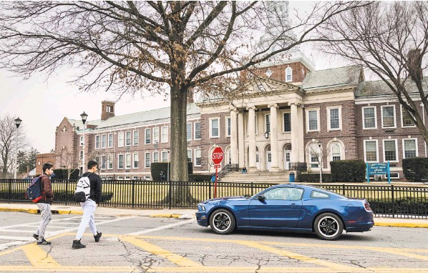
At John L. Miller-Great Neck North High School on Long Island, officials plan to turn a former athletic field into a parking lot, despite opposition from some neighbors.
And these are the students’ cars, not the teachers’.
“That’s pretty much what you’re going to see in the student lot here,” said a high school senior, Angela Bazon, 18, as she hopped into her own black Mercedes C-300 after school on a nearby street.
Her parents gave Ms. Bazon the sedan for her 17th birthday, a tradition for many teenagers in this wealthy suburb of New York City.
But finding a place to park at school has become much harder. Even as the number of teen drivers declines nationally, many high schools in well-off communities, like Great Neck North, are seeing an increasing number of students driving to school, with nowhere near enough parking to accommodate them.
The parking challenge is a symptom of a new age of opulence — many families in affluent school districts are far richer than a generation ago and more able and willing to indulge their children.
Now, squeezed for space, Great Neck North plans to add a 97-spot student parking lot, which has come as welcome news to students like Josh Vilinsky, 17, a junior, who says he has to arrive nearly an hour before school just to find street parking for his $62,000 Mercedes coupe, a gift on his most recent birthday.
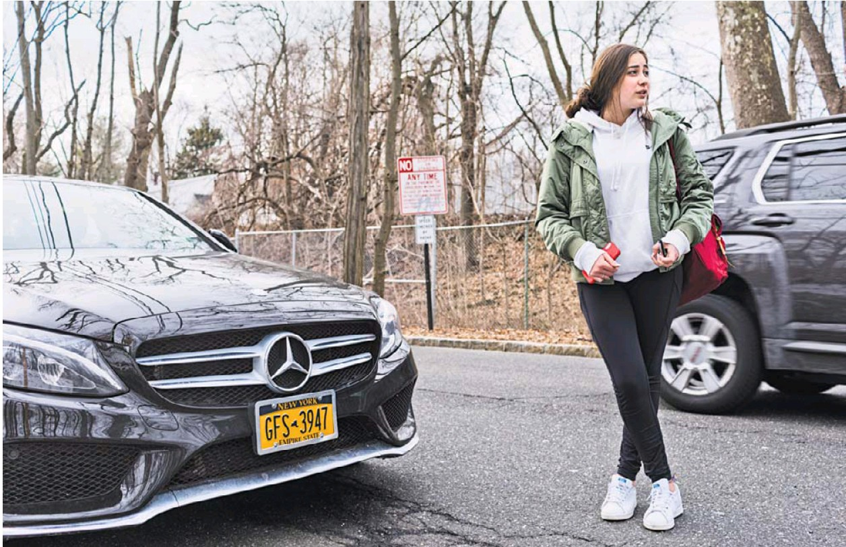
The school’s plan to pave over one of its former athletic fields to create the lot, however, has provoked a backlash from residents who call the $652,000 project too expensive and say it will attract more traffic and deprive the neighborhood of precious green space.
There is also a philosophical objection: Providing more space to park further encourages a culture of entitlement in which expensive cars have become de facto accessories and help dictate social status among privileged students.
“I don’t see any justification for destroying a field to make a parking lot because of this assumption that every kid needs a parking spot,” said Annie Mendelson, a neighbor who opposes the proposed parking lot. “What are we teaching our kids?’’
But Dr. Teresa Prendergast, the superintendent of the Great Neck Public Schools, said that for high school seniors, driving had become a necessity, since many have jobs, internships and other after-school activities.
The high school has also added 200 students in the last decade — its enrollment rising to 1,141 students — as well as teachers and other staff members, and has long outgrown its existing parking capacity of about 100 spots, Dr. Prendergast said.
It is a situation familiar to many New York-area schools, where officials, lacking the real estate to expand parking, use different strategies to try to make more room for student drivers.
At Greenwich High School in Connecticut, parking is in ever-higher demand as “driving has become more and more a rite of passage” for seniors, said its headmaster, Chris Winters.
The school has about 650 seniors and 290 student spots, for which the school awarded 380 permits on a first-come, first-served basis this year.
“It sounds like a recipe for disaster, but not every student drives everyday,” Mr. Winters said. The permits cost $40 a semester and can be revoked for disciplinary reasons.
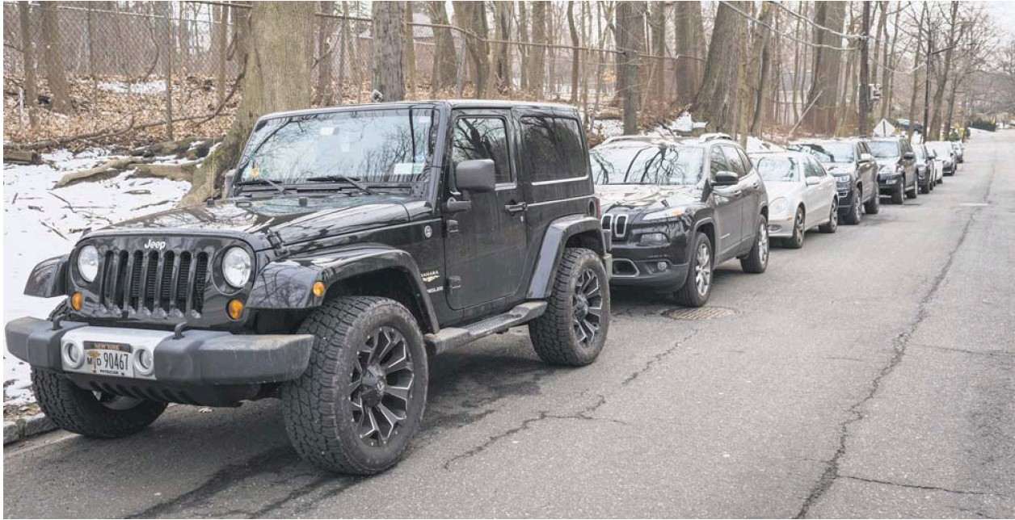
Some schools do have plenty of parking, like Roslyn High School on Long Island, where nearly all 240 seniors who drive can get a space.
But most high schools limit parking to seniors and offer permits by lottery or on a first-come, firstserved basis. Further east on Long Island, Massapequa High School has nearly 600 seniors but only about 20 student parking spots that are distributed through a lottery.
Few students even apply because those with driver’s permits can only drive to and from school but cannot use their cars to come and go during free periods, said the Massapequa principal, Patrick DiClemente, citing parking lot safety as the reason the school imposed the rule. Instead, students compete for spots on surrounding residential streets, which has prompted many homeowners to request signs in front of their property forbidding parking during school hours.
Cassidy Glum, a senior sitting in her 10-year-old Chrysler 300 near the school, said that one perquisite of being a senior was being able to enjoy some privacy during a free period, to study and use phones, rather than staying in school.
Another reason many high school upperclassmen would rather drive is to avoid taking a school bus — that big, yellow abomination known as the “loser cruiser” is the ultimate embarrassment. Ms. Glum said she took the school bus recently while her car was being repaired, “and when I told my friend I took the bus, she said, ‘Are you kidding?’”
Rachel Ozari, 17, a senior at Great Neck North who drives a 2018 Jeep Cherokee, said that most conversations among teenagers begin with questions about the type of car they drive.
Having a luxury car does not exactly divide the cool from the uncool, Ms. Ozari said, “but anything you can go fast in and show off with actually boosts your status.”
Horace Greeley High School in Chappaqua, N.Y., has 360 seniors and 250 daily spots available to whoever claims them first, said the principal, Robert Rhodes. Some students recently proposed a space-sharing system for 40 coveted spots closest to the school.
Relegated to off-campus parking, juniors at Horace Greeley have turned to “a market solution” by persuading nearby homeowners to rent them daytime driveway space for a small fee, Mr. Rhodes said. Some juniors have even paid seniors for parking, or use expired tags, despite the risk of being towed and fined by a company contracted by the school.
When the tow truck is spotted, “The kids pick up their phones and text each other” a warning, Mr. Rhodes said.
At Plainview-Old Bethpage John F. Kennedy High School on Long Island, bus ridership is low, with upperclassmen driving and younger students getting rides from parents, said Dr. Lorna Lewis, the district superintendent.
The school has 120 student parking spaces for 400 seniors. The spaces are administered by lottery to seniors who take a driving safety class, Dr. Lewis said. The idea of decorating student parking spots was floated recently, she said, and one student suggested emblazoning her space with the message: “If you can read this, I’m late for class.”
At Great Neck North, the school issues 137 parking passes on a firstcome, first-served basis and only to the school’s 285 seniors, of which perhaps 170 drive to school, Dr. Prendergast said. Students who cannot park on school property are left scrambling for street parking, leading to long walks from their cars and sometimes parking tickets.
Ms. Mendelson, the neighbor, said the school district did not notify residents about the project, but instead slipped it into a $68 million bond referendum with more than 100 items that was approved last year by voters in the school district.
About 450 residents have signed a petition rejecting the parking lot, said Ms. Mendelson, who believes that the district should hold another vote on the project, which has yet to receive necessary approval from state education officials.
But Dr. Prendergast said the school district publicized the project extensively, including holding more than 30 public presentations.
The lot would replace a field that is no longer usable for athletics and is often muddy and a breeding ground for mosquitoes, said Dr. Prendergast, adding that a 30-foot-wide undisturbed natural border would remain around the lot, along with 60 new trees and a new drainage system.
As far as the necessity for the lot, she said, “The No. 1 issue is student safety.”
For her part, Ms. Bazon noted that having a spiffy Mercedes does not help her claim a good parking space. She would prefer practicality over luxury any day.
“I’d drive an old Honda,” she said, “as long as it gets me there.”

