The Best Nanny Money Can Buy
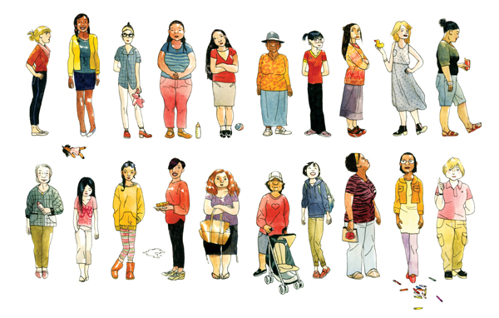
Illustrations by Jillian Tamaki

By ADAM DAVIDSON Published: March 20, 2012 NY Times

It took Zenaide Muneton 20 seconds to convince me that she was the perfect nanny. Short and dark-haired, she has a goofy, beaming smile and knows how to make everything fun for a little kid. Time to brush your teeth? She shakes her hands and does a pantomimed teeth-brushing dance. Bath time? She pumps her arms up and down in a going-to-the-tub march. After I told her I’d love to hire her, she smiled and thanked me.
Adam Davidson translates often confusing and sometimes terrifying economic and financial news.

Then we both laughed, because there is no way I could possibly afford her. As one of New York City’s elite nannies, Muneton commanded around $180,000 a year — plus a Christmas bonus and a $3,000-a-month apartment on Central Park West. I should be her nanny.
I began researching this bizarre microeconomy shortly after my wife and I started looking for someone to watch our son for a few hours a week. We met with several candidates, all of whom had good references and seemed fine with him. Still, we weren’t sure how to judge them. Should we hire the one who seemed to be the most fun? The most experienced? A native English speaker or someone who could speak a foreign language to him? Someone with a college degree? A master’s?
We had no idea. But I began to wonder if price conveyed any important information about the nanny market. All the candidates we spoke with charged about $15 to $18 per hour, which, though standard in our Brooklyn neighborhood, seemed like a bargain when I learned that some nannies charge considerably more than double that rate. Would my son suffer with a midmarket nanny?
This fear led me to the Pavillion Agency, which specializes in finding domestic workers for New York City’s wealthy. Pavillion introduced me to Muneton, 49, who grew up in “a very poor family” in São Paulo. In 1990, she befriended a young American woman who had relocated to Brazil. When Muneton invited her to her family’s home, the woman saw her natural ease with children and suggested that she move to America and become a nanny. Within a few months, Muneton was caring for the children of a rich family in South Carolina for only $100 a week.
When Muneton started working through Pavillion in 2002, however, she increased her salary to $85,000 a year. As she gathered sterling recommendations, she began increasing her pay. Eventually she worked for some of the country’s wealthiest people, whom she accompanied on private jets to many of the world’s most exclusive resorts. Today, she says, “there are no more poor people in my family.” Muneton bought a nice house for her mother, a condo for her sister and a taxi cab each for two of her brothers. She also owns a beach house in Brazil, a penthouse in Miami and two properties (a six-unit building and a duplex) in Los Angeles.
How does a nanny earn more than the average pediatrician? The simple answer is hard work — plus a strange seller’s market that follows a couple of quirky economic principles. A typical high-priced nanny effectively signs her (and they are almost always women) life over to the family she works for. According to Cliff Greenhouse, Pavillion’s president, that kind of commitment is essentially built into the price. Many clients are paying for the privilege of not having to worry about their child’s care, which means never worrying if their nanny has plans. Which, of course, she can’t, pretty much ever.
And, alas, it seems that there just aren’t enough “good” nannies, always on call, to go around. Especially since a wealthy family’s demands can be pretty specific. According to Pavillion’s vice president, Seth Norman Greenberg, a nanny increases her market value if she speaks fluent French (or, increasingly, Mandarin); can cook a four-course meal (and, occasionally, macrobiotic dishes); and ride, wash and groom a horse. Greenberg has also known families to prize nannies who can steer a 32-foot boat, help manage an art collection or, in one case, drive a Zamboni to clean a private ice rink.
And then there’s social climbing. “A lot of families, especially new money, are really concerned about their children getting close to other very affluent children,” Greenhouse says. “How do they do that? They find a superstar nanny who already has lots of contacts, lots of other nanny friends who work with other high profile families.” There are the intangibles too. “I’m working with a phenomenal Caribbean nanny right now,” Greenhouse says. “She is drop-dead beautiful. Her presentation is such that you’re proud to have her by your children’s side at the most high-profile events.”
My wife and I don’t care about any of that stuff. But it’s hard not to wonder if the nannies who make twice as much an hour as the ones we’re considering are also twice as good. Nannies can be evaluated in the same way as what economists call “experience goods” — like wine, whose value can only be determined after experiencing it. When it comes to experience goods, price can be useful to reject anything below a certain minimum. After all, a $3 bottle of wine or a $5-an-hour nanny are pretty sketchy.
But price is useless — or worse, misleading — in differentiating among the adequate. I’ve often assumed that a $40 bottle of wine is twice as good as a $20 bottle even though the American Association of Wine Economists has essentially proved that the price of wine has almost no bearing on enjoyment. When nonconnoisseurs buy an expensive bottle, they’re acting like new parents hiring a nanny: they’re basically paying for a false sense of assurance. Or hoping to impress somebody.
Actually, nanny prices might be even more misleading than the wine market. They also bear resemblance to “credence goods,” an economic term for something — whether a jar of vitamins or an auto tuneup — whose true value can never quite be determined. You’re more likely to overpay for a credence good in the hope that a higher cost increases the likelihood of a benefit.
So if economics can’t fairly convey the price of a nanny, what does? Jeanne Brooks-Gunn, a director at Columbia University’s National Center for Children and Families, reassured me that academics know, roughly, nothing about how nannies impact children. There has not been any sort of serious study on nanny quality, she says, because it would be nearly impossible to get permission from nannies (often paid under the table) or their employers. Also, most child-development research is dedicated to at-risk children, and the kids of people with the resources to hire nannies don’t typically qualify.
Brooks-Gunn did, however, have some advice for what can make a good nanny. The single-most important characteristic is the extent to which a nanny is responsive to the child’s mood and interests. Brooks-Gunn said that when she chose a nanny, she simply handed her son to every candidate she interviewed and chose the one who responded most sensitively.
After our talk, I spoke with one of her graduate students, Erin Bumgarner, who moonlights as a part-time nanny for around $17 an hour — the same amount that Park Slope parents pay to immigrant nannies with no college education. I couldn’t think of any other field in which people with such disparate educational backgrounds could make the same amount. But Bumgarner told me it makes sense. She is willing to work for only parents she likes — she already quit one well-paying job for this reason — and who allow her to focus on her school work. The value of that is also built into the price. Even if it costs her a Central Park West apartment.
Adam Davidson is the co-founder of NPR's "Planet Money," a podcast, blog and radio series heard on “Morning Edition,” “All Things Considered” and “This American Life.”

A version of this article appeared in print on March 25, 2012, on page MM18 of the Sunday Magazine with the headline: The $200,000 Nanny Club.

