Without Parents or Lawyers, Thousands of Children Brave Chaos of Immigration Courts Alone
An overwhelmed system struggles to meet President Obama’s order to fast-track deportation hearings on 62,000 lone child migrants.
Karen Houppert August 25, 2014

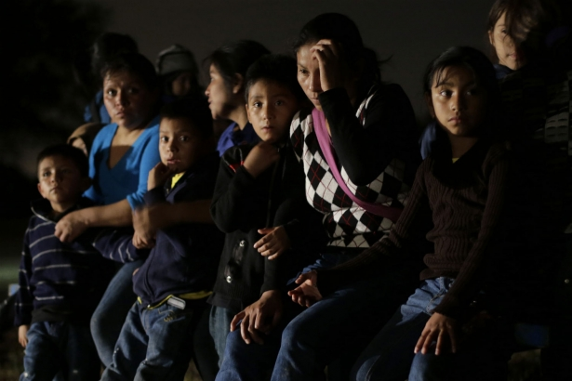
Immigrants from Honduras and El Salvador who crossed the US-Mexico border are stopped in Granjero, Texas. June 25, 2014. (AP Photo/Eric Gray)
Last week, thousands of children who crossed the US border alone, illegally, were rushed into the nation’s courts under President Barack Obama’s recent mandate to expedite their deportation cases. In an effort to stanch the flood of unaccompanied child migrants from Honduras, El Salvador and Guatemala, Obama has ordered federal immigration judges to jump-start their cases—whether or not the children have lawyers to represent them. The courts have been slammed. Here is the scene in New York’s federal immigration court at 10:25 Thursday am—multiply it by 62,000.
A slender 12-year-old girl sits before a judge. She wears a ruffled blue dress, a black cardigan and sandals that look brand new. Her long brown hair is pulled back in a tight ponytail, and she clutches her hands tightly in her lap.
She has no parent present. She has no lawyer. She speaks no English. She sits forward in her seat listening intently.
“Good morning. What language do you speak best?” Judge Elizabeth Lamb asks through an interpreter.
“Español,” the girl says. With the interpreter translating, the judge runs through a quick series of questions.
“Please tell me your name.”
“Ana Torres.” (Since her parents were not present to consent to the publication of her real name, Ana Torres is a pseudonym.)
“Ana, my name is Judge Lamb. The woman speaking to you is an interpreter because I can’t speak Spanish. This lady sitting over here is a lawyer for the government. Do you know your address where you live?”
Ana thinks hard and laboriously recites an address.
“When did you move here?”
“July 3.”
No one present seems to know many of the details of Ana’s life. Later, I will learn that she had lived with her grandmother in Honduras and was sent—without any family—to travel to the United States where she planned to live with her mother in New York. But “men with guns” (presumably border patrol) stopped her group in Texas, and she was sent to an immigration detention center. She doesn’t know the name of place where she was in Texas, but she was afraid, she tells me later, and “cried a lot.” They kept her for two weeks, Ana says.
“I’m going to give you this blue piece of paper and that’s very important,” Judge Lamb says. “Whenever you move, you have to give me within five days of your move this form with your new address.” The judge explains why. “We sent you this notice to come in and the Post Office returned [the letter]. So that’s why this is very important. Do you understand what I’m saying?”
“Yes.”
“Now who is that gentleman sitting next to you?”
“He’s a brother of the church.”
“Where are your parents?”
“My mother is at home.”
“Home where? In the US?”
“Yes.”
“Do you know why she didn’t come with you today?”
“Because she is sick.” (Later, the man from the church will explain that Ana’s mother was afraid to come because she herself is undocumented.)
“And where is your father?”
“I don’t have one.”
“I’m going to speak to your friend here,” the judge says and turns to 38-year-old Alex Guerra, who explains that he knows Ana’s mother from church and that she asked him to come here with Ana.
The judge turns back to Ana. “You don’t have a lawyer, right?”
“Right.”
“I think you need some time to get a lawyer,” she says, explaining that Ana is not required to have a lawyer but that it would probably make things easier for her if she had one. “I’m going to give you a list of lawyers who charge little or no money,” she says and tells the girl to come back on October 22. “Come back to this floor, but a different room. Courtroom 15.… So when you get off the elevator just ask someone where is room 15, okay?”
Ana nods.
As Ana and Alex leave the room, the judge turns to the next child on the docket. “Good morning. What language do you speak best?”
* * *
Judge Lamb would repeat this line of questioning again and again—twenty-three times before noon. Two floors below, Judge Barbara Nelson whipped through a docket of twenty-nine children before lunchtime. Across the country, in Texas, Florida, California and Arizona, judges are similarly processing the parade of 62,000 lone migrant children who’ve entered the country illegally since October.
This summer, President Obama ordered that children be moved to the front of the line and mandated that unaccompanied minors appear in court within twenty-one days of their arrival and within twenty-eight days of their arrival if they’ve traveled here with a parent. New York immigration judges have cleared their calendars to expedite these cases and anticipate initiating deportation hearings on 600 children a month, compared to the usual average of 100. But this fast-track approach may violate the children’s due-process rights—and certainly makes it impossible to properly investigate cases and collect documentation that might affect deportation proceedings.
Immigration advocates and lawyers say disaster looms. “Immigration law is extremely complicated—and with children, more so,” says Lenni Benson, a New York Law School professor and director of Safe Passage, a nonprofit that provides legal assistance to immigrant children in the state. The training materials her organization hands out to pro bono volunteers run hundreds of pages and the flow chart she presented at a White House briefing on August 6 to explain the process looks like a blueprint for tiling a floor—in a vast subway station.
For example, some children may qualify for Special Immigration Juvenile Status if they were abused, neglected or abandoned by one or both of their parents. But the road to permanent resident status requires a trip through federal immigration court, local family court, Homeland Security’s Citizenship and Immigration services, back to federal immigration court and back to Citizenship and Immigration—a process rife with potential missteps for children who do not even have a right to an attorney.
Benson, who works with a temporary coalition of immigration advocates that calls itself ICARE, put out an emergency call for volunteer lawyers and law students this month—and got a terrific response. But there was a sense at 26 Federal Plaza last week that they were standing with their fingers in a dike.
“The numbers are hard to predict exactly,” says Benson who explains that there are typically 6000 child immigration cases pending there, which is approximately 12 percent of the court’s work. She expects another 3,500 by the end of September.
While it is obvious to anyone who spends two minutes in the courtroom that these children need attorneys—some don’t even know their address when the judge asks them; others nod agreeably when Judge Lamb tells them to stay away from notarios, faux-lawyers with big promises and bigger fees—the task and the timeline is overwhelming.
Please support our journalism. Get a digital subscription for just $9.50!
Most of the children arriving in court on Thursday had a Notice to Appear that they were given when they were released from detention but have little sense of what that means.
The scene is hectic: A 12-year-old boy in a baseball cap who fears deportation cries while some Spanish-speaking teenagers try out their English saying, “How are you? How are you?” over and over to one another. Five law students, eight interpreters and nine attorneys who’ve volunteered to screen the children to see if they might get them pro bono representation in the future huddle in groups whispering. An information board in the hallway reads: “Do you just want to go home? Take packet #1. Do you need a lawyer? Take packet #2…. Are you afraid to return to your country? Take packet #6.”
Astrid Avedissian, who graduated from law school in May and is waiting for results from the bar exam, tried to help 12-year-old Ana Torres. “She had no documents with her and I had never met her before today,” she says. “I asked this little girl about her journey here and what her life was like in Honduras.” Ana told Avedissian that her mother left her with her grandmother when she was 5 and moved to New York. She has an 8-year-old sister here who was born here; she had never met her before. She has no father. Other information is scant.
In two weeks, Ana will start seventh grade. Math is her favorite subject, she tells me. She would like to be a doctor when she grows up. “I like to help people,” she says.

Read Next: Zoë Carpenter on immigrants rights groups pushing Obama for bolder excutive action

