6 Oct 2016 The New York Times By RICK GLADSTONE

Witness to a Perilous Crossing
ZoomBookmarkPrintListen
“I’ve seen a lot of death, but not this thing,” Aris Messinis, an Agence France-Presse photographer, said of boats packed tight with African migrants. In one, migrants had to climb over the dead. Many were in the cargo hold, an image evoking the slave trade. It began with blips on a radar screen, 12 miles off the Libyan coast. As the rescuers approached, they found overloaded wooden vessels and rafts that evoked scenes of the slave trade.
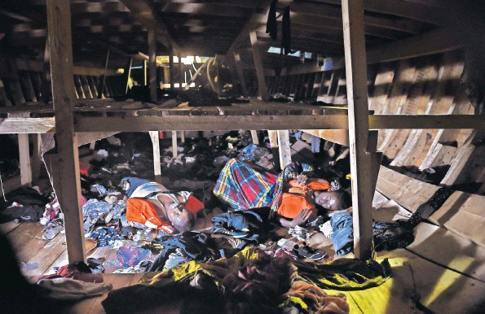P Corpses found below deck. The International Organization for Migration said at least 38 migrant bodies were recovered Monday and Tuesday.
Hundreds of African migrants were crammed into boats headed for Italy. More than two dozen people were dead in one boat alone, asphyxiated from the crush aboard.
The passengers — from Eritrea, Ethiopia, Somalia, Nigeria and other sub-Saharan countries — were found by the rescue boat Astral on Tuesday, part of a wave of more than 11,000 rescued in the Mediterranean by aid groups and the Italian Coast Guard this week.
One large wooden boat may have held 1,000 people, roughly five times its capacity.
In one of the boats, holding roughly 150 people, rescuers found 29 bodies, said Aris Messinis, an Agence France-Presse photographer on the Astral.
Migrants crammed below deck were packed so tightly they struggled to get out. “Many of them haven’t seen the sea in their whole lives,” said Laura Lanuza, a spokeswoman for Proactiva Open Arms, a Spanish aid group that operates the Astral.
Despite a drop in sea crossings to Europe by migrants this year, more than 3,000 have died in perilous crossings from Libya. Rescue officials attributed the increase in sea crossings in recent days to a stretch of good weather.
The wooden vessel’s cargo hold contained two-thirds of the roughly 1,000 people found aboard, Ms. Lanuza said, calling the conditions “just like a slavery boat — the same.”
“I’ve seen a lot of death, but not this thing,” said Mr. Messinis, 39, who has covered the conflicts in Libya and Syria. “This is shocking and this is what makes you feel you are not living in a civilized world.”
